MONSTER COOKIE BARS  COOK TIME: 23 min  SOURCE:  #sweet #comfort-food #baking | 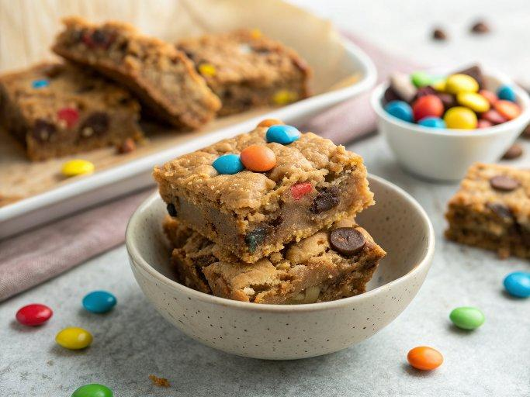

INGREDIENTS  - 4 tbsp (57 g) unsalted butter, (at cool room temperature)  - 3/4 cup (203 g) natural peanut butter, (very well stirred*)  - 1/2 cup (100 g) granulated sugar  - 1/2 cup (100 g) lightly packed dark brown sugar**  - 1 large egg plus 1 egg yolk, (at cool room temperature)  - 1 1/2 tsp vanilla extract  - 2 cup (480ml)s (198 g) old-fashioned rolled oats  - 1 tsp baking soda  - 1/4 tsp fine sea salt  - 1/2 cup (85 g) semisweet chocolate chips, (plus extras to top cookie bars, optional)  - 1 cup (200 g) M&M candies, (plus extras to top cookie bars, optional)  - Flaky sea salt, (for topping, optional) | PREP  COOK  1. Preheat the oven to 350°F (175°C). Line an 8 by 8-inch (20cm) metal baking pan with foil or parchment paper. Spray with nonstick cooking spray.  2. In the bowl of an electric mixer, beat the butter, peanut butter, granulated sugar, and brown sugar on medium-high speed until smooth and creamy, 2 to 3 minutes. Scrape down the bottom and sides of bowl. Beat in the egg, egg yolk, and vanilla. Add the oats, baking soda, and salt, mixing on low speed until combined. Fold in the chocolate chips and M&Ms with a rubber spatula.  3. Press dough evenly into prepared pan. Optional: Dot the tops of the bars with additional M&Ms and/or chocolate chips before baking.  4. If time permits, cover pan with plastic wrap and refrigerate for 24-48 hours to yield a chewier, more flavorful bar.  5. Bake for about 23-25 minutes, or until the bars no longer look wet on top, the center appears set, and the top is golden brown. Set pan on a wire rack and sprinkle flaky sea salt on top, if desired. For best texture and to allow the peanut butter flavor to fully develop, let bars sit until completely cooled before slicing and enjoying. It’s worth it, promise!  6. Cookie bars can be stored in an airtight container at room temperature for up to 3 days.  PLATING

