PEPERONATA  COOK TIME: 38 min  SOURCE:  #quick #comfort-food #vegetable | 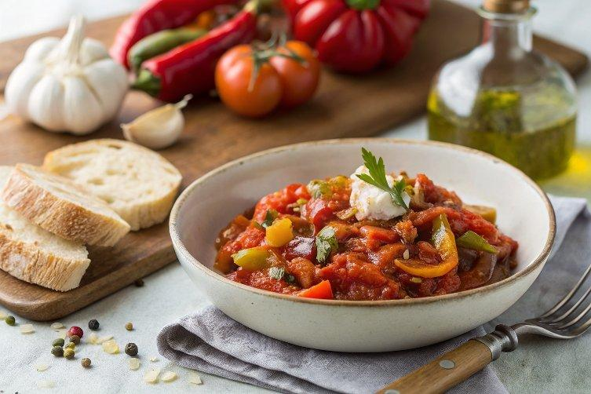

INGREDIENTS  - 3 tbsp oil  - 3 finely sliced shallots  - 3 tbsp tomato purée  - 4 crushed garlic cloves  - 3 finely sliced peppers  - 2 roughly chopped tomatoes  - 1/2 tbsp red wine vinegar | PREP  COOK  1. Heat the oil in a large frying pan over a medium heat. Stir in the shallots and tomato purée with the salt. Cook for 5-7 mins until caramelised and softened, then stir in the garlic cloves. Cook for 1-2 mins until fragrant. Mix in the finely sliced peppers and the roughly chopped tomatoes. Cook for 25-30 mins, stirring now and then, until everything is jammy. Stir in the red wine vinegar and season to taste. Leave to cool and keep in an airtight container in the fridge until needed. Will keep chilled for up to four days. Use this to make our lemony flatbreads with broccoli & mascarpone or our lemon orzo with trout.  PLATING

