MASHED SWEET POTATOES BRULEE  COOK TIME: 40 min  SOURCE:  #comfort-food #vegetable #sweet | 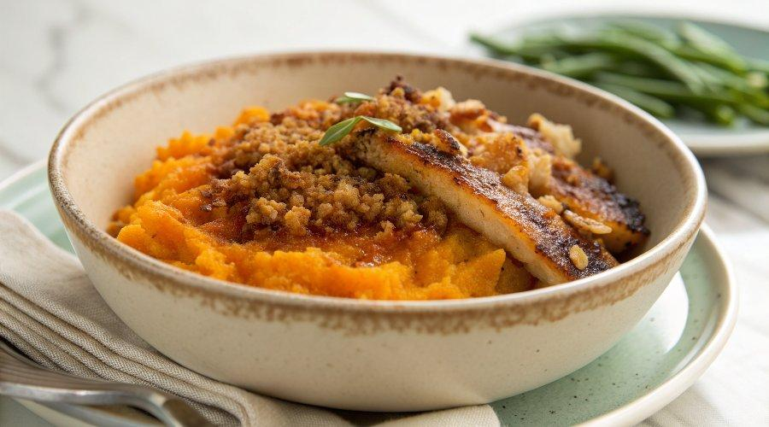

INGREDIENTS  - 5 1/2 lbs sweet potatoes (peeled and boiled until soft (6 cups cooked)  - 3/4 cup 1% milk  - 3 tbsp whipped butter (softened)  - 1/2 tsp kosher salt  - 1/4 tsp ground cinnamon  - 1/8 tsp ground nutmeg  - 1/2 cup unpacked light brown sugar | PREP  COOK  1. When the potatoes are cooked and soft, combine them with milk, butter, salt, cinnamon and nutmeg in a large bowl and mash or puree until smooth.  2. Spoon into a 9 x 9 or 11x7-inch (28x18cm) baking dish. Bake at 350 covered, until heated through, about 20 minutes. If making ahead, and baking from the refrigerator, add more time as needed until the center is hot.  3. Preheat the broiler.  4. Sprinkle 1/2 cup brown sugar evenly over top.  5. Broil about 6-inch (15cm) from the flame until the sugar melts and becomes caramelized, careful not to burn. About 2 to 3 minutes.  6. Let it stand until the melted sugar hardens (about 5 minutes).  PLATING

