TURKEY SANTA FE ZUCCHINI BOATS  COOK TIME: 1h 20m  SOURCE:  #healthy #comfort-food #quick | 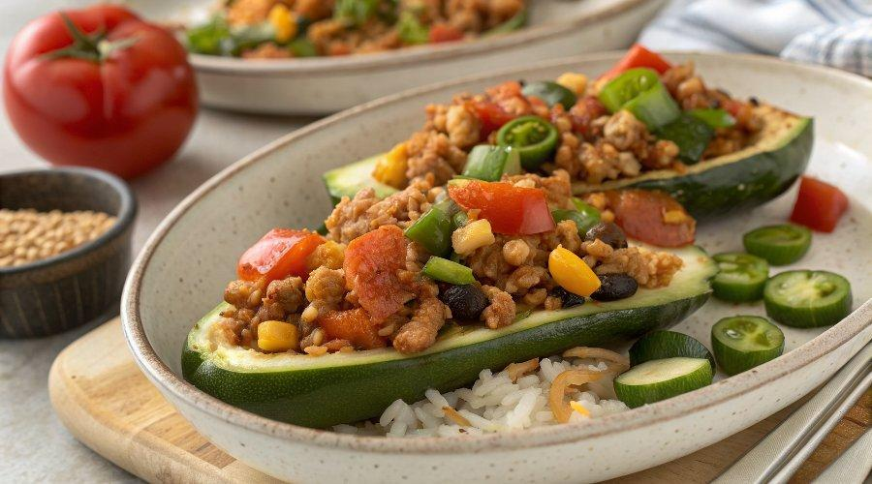

INGREDIENTS  - 12 oz 93% lean ground turkey  - 3/4 cups canned black beans (rinsed and drained)  - 3/4 cups corn kernels (fresh or frozen)  - 1 hot pickled serrano pepper (chopped (or jalepeño) more to taste)  - 1 large diced tomato  - 1 cloves garlic (minced)  - 1/4 cup chopped onion  - 2 tbsp chopped cilantro  - 1 tsp cumin  - kosher salt to taste  - 5 medium zucchini (7 oz each, cut in half lengthwise)  - 1/2 cup jarred mild salsa  - 15 tbsp shredded reduced-fat Mexican blend cheese | PREP  COOK  1. Bring a large pot of salted water to boil. Preheat oven to 400°F (200°C).  2. Using a small spoon or melon baller, hollow out the center of the zucchini halves, leaving 1/4-inch (10cm) thick shell on each half. Chop the scooped out flesh of the zucchini in small pieces and set aside 3/4 of a cup to add to the turkey filling, (squeeze excess water with a paper towel) discarding the rest or save to use in another recipe.  3. Drop zucchini halves in boiling water and cook 1 minute. Remove from water.  4. In a large skillet brown the turkey and season with salt. When the turkey is browned, add onion, garlic, black beans, cilantro, serrano pepper, diced tomatoes, reserved zucchini and cumin. Mix well and simmer on low, covered for 20 minutes.  5. Remove lid, add corn and simmer an additional 5 minutes or until all the liquid reduces.  6. Place the salsa in the bottom of a large baking dish (or two medium size dishes) and place the hollowed out zucchini cut side up in the dish.  7. Using a spoon, fill the hollowed zucchini boats dividing the filling equally, about 1/3 cup in each, pressing firmly. Top each with 1 1/2 tablespoons of shredded cheese.  8. Cover with foil and bake 35 minutes until cheese is melted and zucchini is cooked through.  PLATING

