VEGAN RED PESTO  COOK TIME: 5 min  SOURCE:  #quick #healthy #vegan | 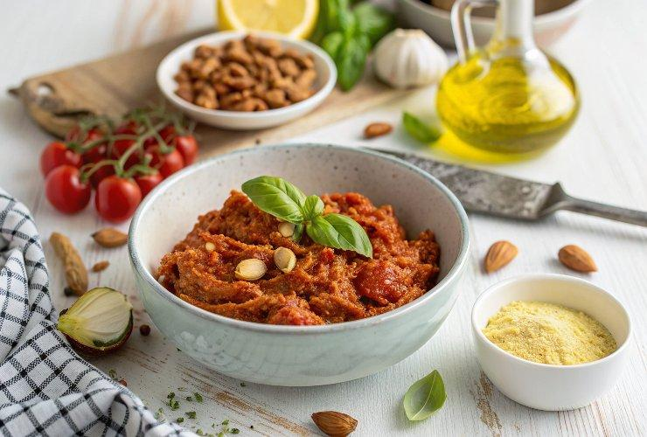

INGREDIENTS  - 1/2 cup raw almonds  - 1 cup (240ml) oil-packed sun-dried tomatoes  - 1/2 cup oil from jar of sun-dried tomatoes  - 1/2 cup fresh basil leaves  - 2 garlic clove  - 1 Tbsp nutritional yeast flakes  - 1/2 lemon  - 1/2 tsp salt  - 1/4 tsp ground black pepper | PREP  COOK  1. Heat a small pan over medium-high heat, and toast the almonds for 4 - 5 minutes, stirring throughout.  2. Add the toasted almonds and all the remaining ingredients to a food processor, and blend. Enjoy with crackers or as a spread on your favourite sandwich!  PLATING

