CHOCOLATE LOAF CAKE  COOK TIME: 50 min  SOURCE:  #chocolate #baking #comfort-food | 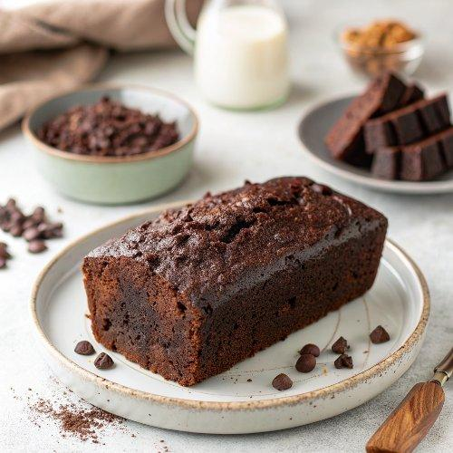

INGREDIENTS  - 1 cup (240ml) boiling water  - 5 oz bittersweet chocolate, (best quality best quality such as Ghirardelli)  - 2 tbsp natural unsweetened cocoa powder, (such as Hershey's)  - 1 tsp instant coffee granules, (such as Nescafé)  - 1 cup (2 sticks) unsalted butter, at room temperature  - 2 cups (480ml) + 2 tbsp all-purpose flour, (spooned into measuring cup and leveled-off, divided)  - 1 tsp baking powder  - 1 tsp salt  - 1 cup (240ml) semisweet chocolate chips, (best quality such as Ghirardelli)  - 1 cup (240ml) granulated sugar  - 1 cup (packed) dark brown sugar  - 3 extra-large eggs, (at room temperature)  - 2 tsp vanilla extract | PREP  COOK  1. Preheat the oven to 350°F (175°C) and set an oven rack in the middle position. Grease two 8 x 4-in (20 x 10-cm) loaf pans with nonstick cooking spray with flour, such as Baker's Joy or Pam with Flour.  2. Pour the boiling water into a 2-cup (480-ml) glass measuring cup, add the bittersweet chocolate, cocoa powder, and coffee granules, and stir until the chocolate melts. Set aside to cool for at least 15 minutes.  3. In a medium bowl, whisk together the 2 cups (480ml) flour, the baking powder, and salt and set aside. In another bowl, toss the chocolate chips with the remaining 2 tablespoons flour and set aside.  4. In the bowl of an electric mixer fitted with the paddle attachment or beaters, beat the butter, granulated sugar, and brown sugar together on medium speed for 2 minutes. With the mixer on low, add the eggs, one at a time, and then the vanilla, scraping down the bowl with a rubber spatula. The mixture may look at little curdled at this point; that's okay. Alternately in thirds, add the flour mixture and the chocolate mixture, beginning and ending with the flour. (Don't worry if there are a few bits of unmelted chocolate in the chocolate mixture.) Fold in the chocolate chips with a rubber spatula. Divide the batter equally between the prepared pans, smooth the tops, and bake for 45 to 55 minutes, until a toothpick inserted in the middle comes out clean. (Test in a few places because you might hit a warm chocolate chip.) Cool in the pans for 15 minutes, turn out on a cooling rack, rounded side up, and allow to cool to room temperature. Slice with a serrated knife.  PLATING

