LAMB & CHICKPEA KOFTAS  COOK TIME: 43 min  SOURCE:  #comfort-food #grilled #protein-rich | 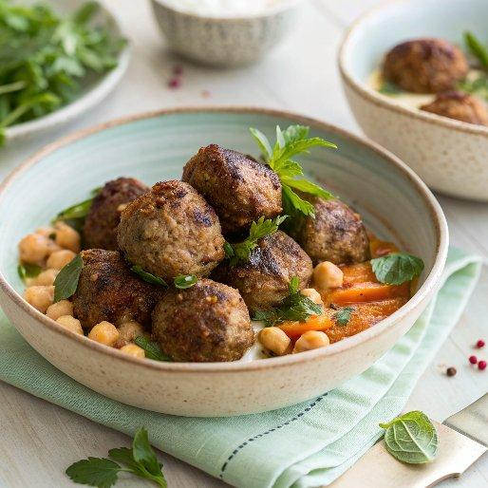

INGREDIENTS  - 1 x 700 g jar or 2 x 400 g tins of chickpeas  - 1 lemon  - 500 g higher-welfare lamb mince  - olive oil  - 6 wholewheat tortillas  - 700 g carrots  - 1 bunch of mint (30 g)  - extra virgin olive oil  - 100 g feta cheese  - hot chilli sauce, to serve | PREP  COOK  PLATING

