HARISSA ROAST CHICKEN TRAYBAKE  COOK TIME: 1h 30m  SOURCE:  #roast #comfort-food #one-pan | 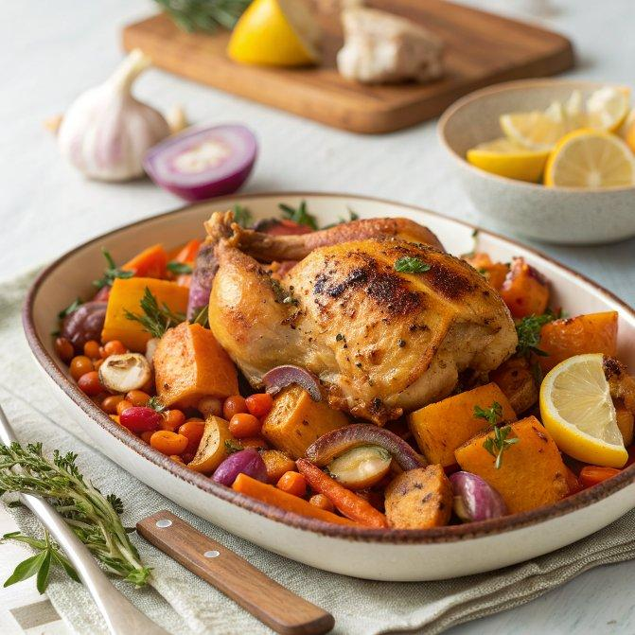

INGREDIENTS  - 1/2 a butternut squash (750 g)  - 2 red onions  - 2 carrots  - 2 mixed-colour peppers  - 1 lemon  - 1 bulb of garlic  - olive oil  - 2 tbsp ras el hanout  - 1 x 1.6 kg free-range chicken  - 1 tbsp rose harissa  - 1 x 700 g jar chickpeas  - couscous, to serve  - natural yoghurt, to serve | PREP  COOK  1. Preheat the oven to 180ºC/350ºF/gas  4.  2. Deseed the squash and carefully cut into large 4cm (2-inch) chunks, peel and quarter the onions, peel and roughly chop the carrots, deseed the peppers and tear into big chunks, and cut the lemon in half.  3. Place it all in a 30cm (12-inch) x 40cm (16-inch) roasting tray with the whole unpeeled bulb of garlic, 2 tablespoons of olive oil and the ras el hanout. Toss it all together with a good pinch of sea salt and black pepper.  4. Add the chicken to the tray, skin side up, and season with sea salt and black pepper. Spoon over the harissa and 1 tablespoon of olive oil and toss well, making sure you get into all the nooks and crannies of the meat. Roast for 1 hour, then tip in the chickpeas, juice and all, and roast for a final 20 minutes, or until gnarly and cooked through.  5. Remove the tray from the oven. Mash the soft garlic cloves into the tray juices, discarding the skins, and squeeze over the jammy lemon. Delicious with fluffy couscous and a dollop of harissa-rippled natural yoghurt.  PLATING

