KANCHA PEPER KOFTA CURRY RECIPE-BENGALI GREEN PAPAYA KOFTA SABZI  COOK TIME: 30 min  SOURCE:  #curry #comfort-food #vegetable | 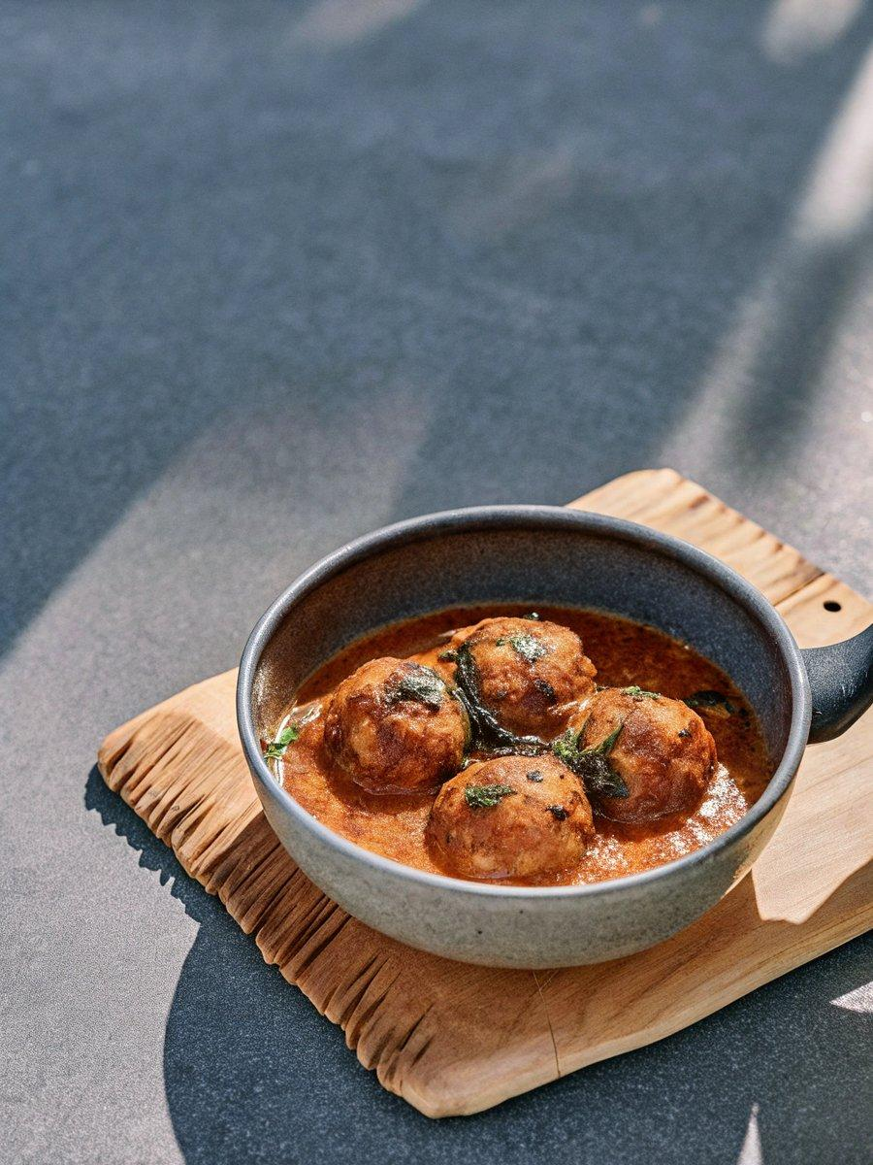

INGREDIENTS  - 2 cup (480ml) Raw papaya grated  - 2-inch (5cm) Ginger grated  - 1 tsp Coriander Powder (Dhania)  - 1 tsp Red Chilli powder  - 1 tsp Cumin powder (Jeera)  - 1 tsp Garam masala powder  - 1/2 cup g flour (besan)  - Salt to taste  - Oil to cook  - 1-1/2 cup Onion ground to paste  - 1 cup (240ml) Homemade tomato puree  - 1 tbsp Garlic grated  - 1-inch (3cm) Ginger grated  - 1 tsp Turmeric powder (Haldi)  - 1 tsp Coriander Powder (Dhania)  - 1 tsp Red Chilli powder  - 1 Bay leaf (tej patta)  - 1 tbsp Garam masala powder  - 1 Dry Red Chilli  - 1 tbsp Sugar  - 2 tbsp Curd (Dahi / Yogurt) beaten  - 1 tsp Kasuri Methi (Dried Fenugreek Leaves)  - 1 tbsp Mustard oil  - Salt to taste | PREP  COOK  1. To begin making Kancha Peper Kofta Curry Recipe-Bengali Green Papaya Kofta Sabzi, first proceed with making koftas.  2. In a big pan, boil about 4 cups (960ml) of water, when it starts bubbling, add grated green papaya. Let it cook for 5- 6 minutes. Drain the papaya stock water and keep aside. Squeeze blanched grated papaya to keep this papaya stock reserved to use it when we need to make the gravy.  3. In a mixing bowl, add blanched papaya, salt, coriander, cumin and red chilli powder.  4. Add besan and garam masala powder and mix it very well to incorporate everything. Make koftas out of it that fits your paniyaram pan.  5. You can either deep fry them in hot oil in a kadai, or make it healthier way in paniyaram pan.  6. Heat enough oil to fry in a deep fry pan and when the oil is hot enough, drop the koftas that you have made and fry till they are cooked and golden brown in colour. Make sure that you do not overcrowd the kadai to make crispy koftas. Drain out into a plate lined with kitchen towel.  7. Or if you are making these koftas in a healthy way in paniyaram pan, heat the paniyaram pan on a medium heat and fill each cavity with cooking oil, and place the koftas in individual cavities. Drizzle a few drops of oil on each kofta.  8. Flip the koftas once you see that the bottom side is browned and cook further till the koftas cook and brown evenly around.  9. Once done, take them out on a kitchen towel and drain out the excess oil, and keep aside till the gravy is made.  1  0. Heat oil in a frying pan or kadai. Once the oil is heated, add bay leaf, dried red chilli and whole garam masala. Roast until a nice aroma arises from the kadai.  1  1. Once the whole spices are oil-roasted, add the onion paste fry a bit then add ginger garlic paste and fry for about 5 minutes or till the onions are cooked.  1  2. Now add tomato puree, red chilli powder, turmeric powder, coriander powder, sugar and salt and fry until the gravy is all bubbling and comes together.  1  3. Add papaya stock and beaten yogurt in the gravy. Let it come to a boil, on medium heat. Then add the fried raw papaya koftas and cook uncovered for about 5 minutes on medium heat or till the koftas seep in the flavours from the gravy.  1  4. Sprinkle kasoori methi on the Kancha Peper Kofta Curry and give a stir and switch off heat. Remove Kancha Peper Kofta Curry into a serving bowl.  1  5. Serve Kancha Peper Kofta Curry Recipe-Bengali Green Papaya Kofta Sabzi for dinner with family along with Garlic Naan Without Yeast Recipe and Parsi Style Baingan Capsicum Ka Salan Recipe.  PLATING

