SHRIMP & MEXICAN CORN FOIL PACKETS  COOK TIME: 15 min  SOURCE:  #quick #grilled #seafood | 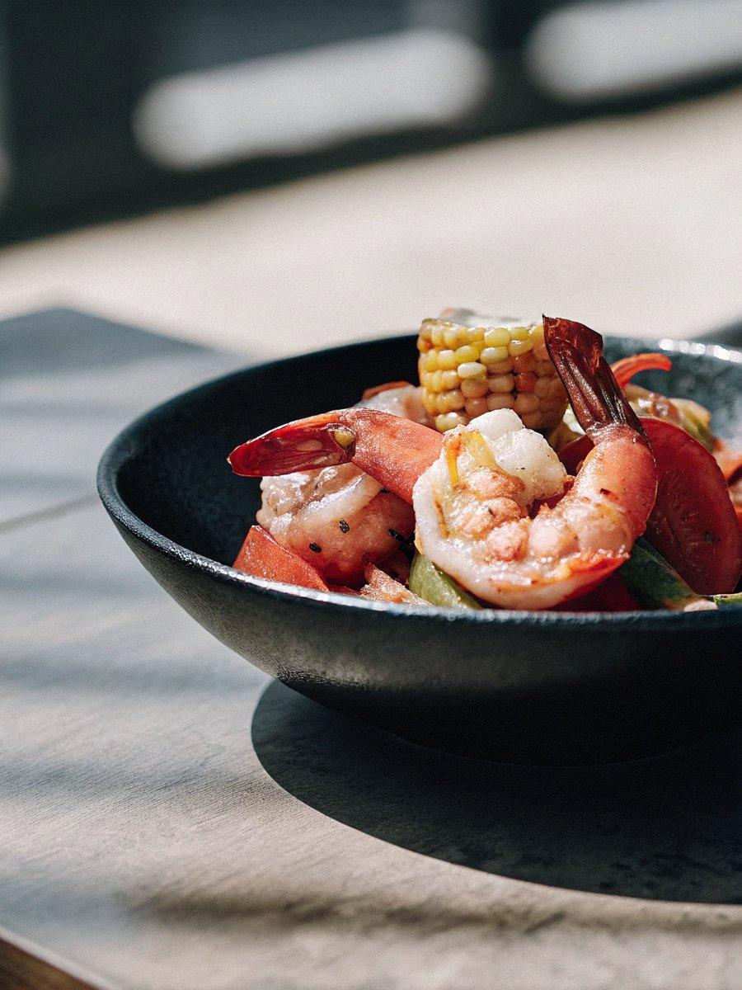

INGREDIENTS  - 2 lb shrimp (medium, peeled and deveined, tails on or off)  - 2 ears corn on the cob (husked, cut into 6 x 1-inch pieces per cob)  - 1 red bell pepper (deseeded and thinly sliced)  - 1 orange bell pepper (deseeded and thinly sliced)  - 1 green bell pepper (deseeded and thinly sliced)  - 1/2 red onion (thinly sliced)  - 2 tbsp olive oil  - 2 cloves garlic  - 1 tbsp taco seasoning  - 1 tsp brown sugar  - 1/4 cup lime juice  - 2 tbsp cilantro leaves (chopped, fresh )  - 1/2 tsp ground cumin  - 2 tbsp mayonnaise  - 2 tbsp sour cream  - 1 clove garlic (finely minced)  - 1/3 cup Cotija (or feta cheese, finely crumbled, or fresh grated parmesan cheese)  - 1/4 tsp chili powder ( plus more for serving )  - 2 tbsp cilantro leaves (finely chopped to garnish)  - 1 lime (cut into wedges) | PREP  COOK  1. Preheat a gas (or charcoal grill), or a grill pan over high heat.  2. Cut four sheets of foil, about 10-12-inch (5cm)es (25-30cm) long. Combine the shrimp, corn, bell peppers and onions in a large bowl. Add the olive oil, garlic, taco seasoning, brown sugar, lime juice, cilantro and cumin; gently toss to combine.  3. Divide shrimp mixture among the four pieces of foil, arranging the ingredients on the centre of each piece. Fold up all 4 sides of each foil packet, covering completely and sealing the packets closed.  4. Place foil packets on the grill and cook until just cooked through, about 6-8 minutes on one side. Flip, and continue to grill on the other side for a further 6 minutes, or until the corn is tender and shrimp are fully cooked. (If using the oven, bake in a preheated oven -- 400°F | 200°C -- on a baking sheet for 25-30 minutes, or until done).  5. While the packs are cooking, mix together the mayo, sour cream and garlic until thoroughly mixed through.  6. Once cooked, drizzle the corn with the crema; top with the cheese and chili powder; garnish packs with the cilantro (or parsley) and serve packets immediately with lime wedges, tortillas, rice, or other sides.  PLATING

