RED CABBAGE SALAD WITH APPLE  COOK TIME: 20 min  SOURCE:  #healthy #quick #refreshing | 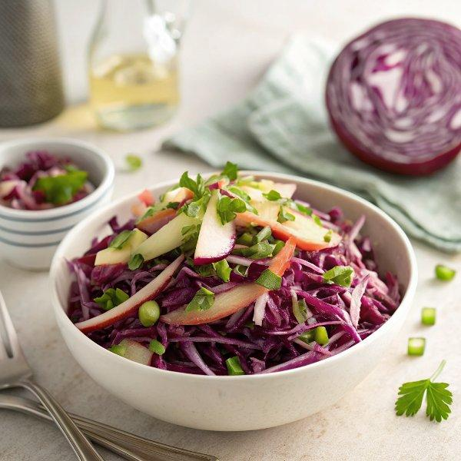

INGREDIENTS  - 1/2 medium red cabbage (6 cups finely chopped)  - 1/2 cup sauerkraut (well drained)  - 1/2 English cucumber (sliced)  - 1 granny smith apple (sliced into thin bite-sized pieces)  - 1/2 cup green onion (chopped)  - 1 Tbsp dill (finely chopped)  - 4 Tbsp extra virgin olive oil  - 1 Tbsp white vinegar (or to taste)  - 1/2 tsp sea salt (or to taste) | PREP  COOK  1. Finely chop cabbage and transfer it to a large mixing bowl.  2. Thoroughly squeeze sauerkraut by the fist-fulls to remove excess moisture until you have 1/2 cup of squeezed sauerkraut then add it to the salad bowl.  3. Add sliced cucumber and granny smith apple, chopped dill and green onion.  4. Drizzle the salad with 4 Tbsp extra virgin olive oil and 1 Tbsp white vinegar and 1/2 tsp sea salt*. Toss the salad well to combine and add more salt and/or vinegar to taste.  PLATING

