BLUE CHEESE + SMASHED AVOCADO AND ROASTED TOMATO GRILLED CHEESE  COOK TIME: 30 min  SOURCE:  #quick #comfort-food #grilled | 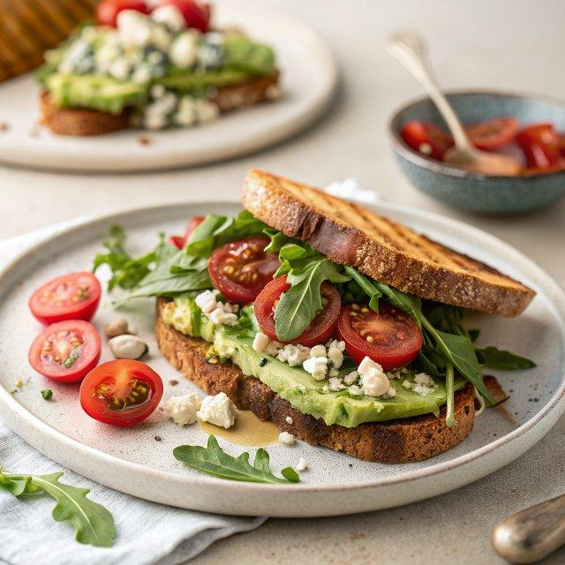

INGREDIENTS  - 1 cup (240ml) grape tomatoes (halved)  - 1 tbsp olive oil  - 1/2 tsp salt  - 1/2 tsp pepper  - 1 avocado (lightly mashed)  - 1 cup (240ml) fresh arugula  - 4-6 oz blue cheese (crumbled)  - 4 slices seedy bread  - softened butter (for spreading) | PREP  COOK  1. Preheat the oven to 400°F (200°C).  2. Grease a baking sheet and add the halved tomatoes. Toss the tomatoes with olive oil, salt and pepper. Roast for 25 to 30 minutes, remove from the oven and set aside. When the tomatoes are finished roasting turn the oven to broil.  3. Lightly mash the avocado with the salt and pepper. Spread one side of each bread slice with softened butter. On the unbuttered sides evenly spread the mashed avocado among the insides of all 4 slices of bread. Add the blue cheese right on top of the mashed avocado. Place the slices of bread on a baking sheet and broil for 30 seconds to 1 minutes. Just until the blue cheese begins to melt. Remove from the oven and heat a skillet over medium heat.  4. Divide the arugula in two and place right on top of the melted blue cheese and then add a handful of the roasted tomatoes. Place the other half of the bread on top to make a sandwich. Place both sandwiches in the skillet. Cook until cheese is melted and both sides are golden brown, at least 3 minutes per side. Lower the heat if the bread gets too brown. Serve immediately  PLATING

