HOMEMADE SHISO PESTO  COOK TIME: 10 min  SOURCE:  #quick #fresh #herb-based | 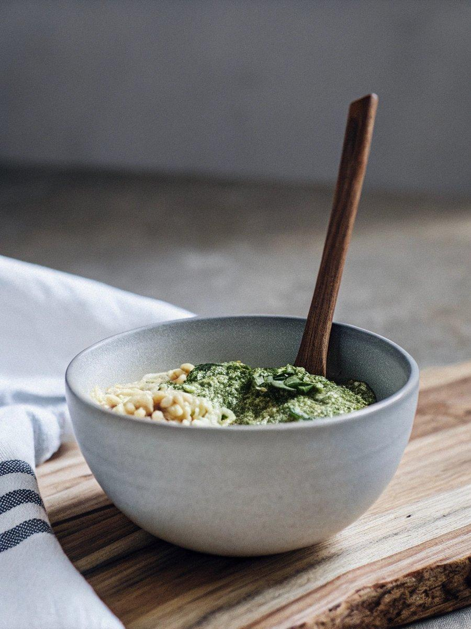

INGREDIENTS  - 1 oz shiso leaves (perilla/ooba) (30 leaves or 25 extra large leaves; you can substitute basil, arugula, baby spinach, kale, or parsley) 30 25  - 3 Tbsp pine nuts (1 oz, 30 g; toasted, preferably; you can substitute walnuts, cashews, or almonds) 1 30  - 2 cloves garlic (peeled)  - 1 oz Parmigiano-Reggiano or Parmesan cheese (a bit less than 1/3 cup if freshly grated; 1/4 cup if pre-shredded) 1/3 1/4  - 1/2 tsp Diamond Crystal kosher salt  - 1/8 tsp freshly ground black pepper  - 1/4 cup extra virgin olive oil (plus a little bit more to cover the pesto in the final step) | PREP  COOK  1. Gather all the ingredients. If time allows, toast the pine nuts first in a non-greased pan for a few minutes until light brown and let cool.  2. Place 1 oz shiso leaves (perilla/ooba), 3 Tbsp pine nuts, and 2 cloves garlic into the bowl of a food processor.  3. Pulse several times until smooth.  4. Add 1 oz Parmigiano-Reggiano or Parmesan cheese, ½ tsp Diamond Crystal kosher salt, and ⅛ tsp freshly ground black pepper.  5. Pulse several times more until incorporated.  6. Add ¼ cup extra virgin olive oil. Note: I never had any issue adding the olive oil all at once. However, if you‘re concerned about emulsification, slowly drizzle in the olive oil with the food processor or blender still running.  7. Process until smooth. Add a touch of extra oil, if required, to help it blend.  8. Stop and scrape down the sides of the food processor with a rubber spatula and run again until the mixture is smooth. Taste and adjust the seasoning with more salt and freshly ground black pepper, if needed.  9. Pour the pesto into a clean, sterlized jar. Cover the pesto with a thin layer of olive oil on top. Close the lid.  1  0. To Serve  1  1. Use Homemade Shiso Pesto in any recipe that calls for traditional pesto. Try it in my Shiso Pesto Pasta recipe!  1  2. To Store  1  3. Store in the refrigerator for 5 days or in the freezer for 3 months (could be longer).  PLATING

