SOBORO BENTO  COOK TIME: 5 min  SOURCE:  #quick #healthy #bento | 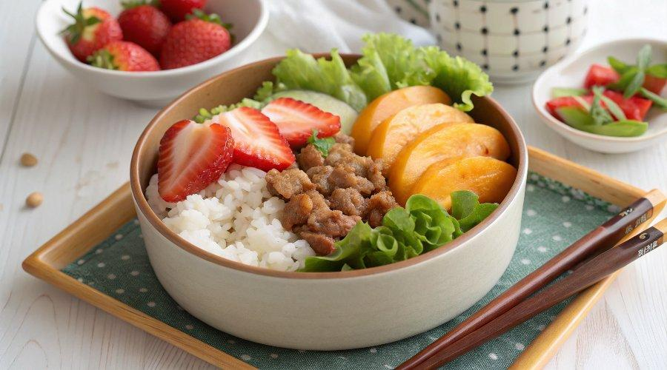

INGREDIENTS  - cooked Japanese short-grain rice  - soboro don (pre-cooked)  - lettuce (for garnish)  - peaches  - strawberries | PREP  COOK  1. Fill up half of the bento box with Japanese rice. Let it cool so that hot/warm rice will not warm up other cool food.  2. Reheat leftover soboro in a frying pan until it's warm thoroughly.  3. Wash lettuce and pat dry. Place nicely in the bento box.  4. Place ground chicken, egg, and green peas on top of rice.  5. Pack peaches and strawberries in an open space in the bento box.  6. Cool down completely before close the bento box cover.  PLATING

