PECAN GRANOLA BARS  COOK TIME: 5 min  SOURCE:  #quick #healthy #no-bake | 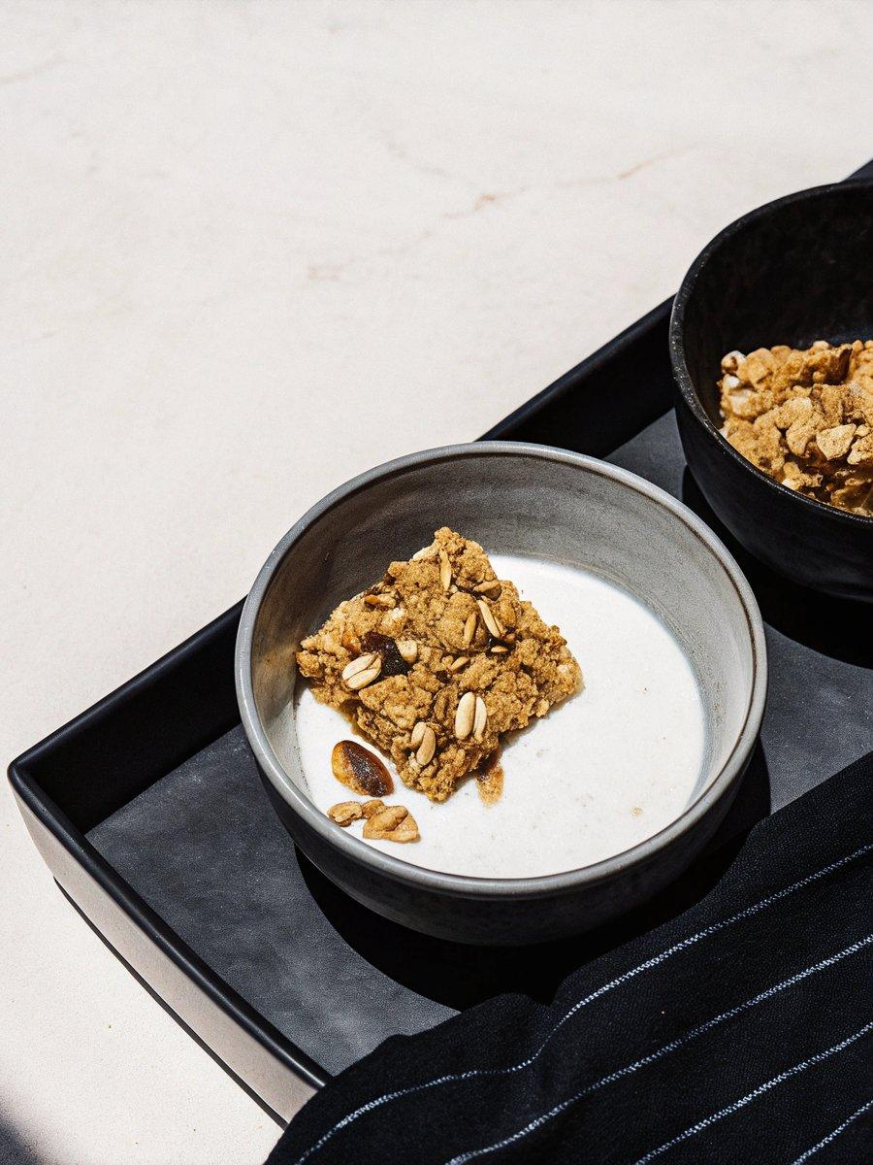

INGREDIENTS  - 1 1/4 cups pecan halves (5 oz)  - 2 cups (480ml) quick-cooking oats (or old-fashioned oats, pulsed briefly in a food processor or blender to break them up)  - 1 tsp ground cinnamon  - 1/2 tsp fine sea salt (if using regular table salt or salted nut butter, scale back a bit)  - 1 cup (240ml) homemade pecan butter* or creamy almond butter or peanut butter  - 1/2 cup maple syrup or honey  - 1 1/2 tsp vanilla extract | PREP  COOK  1. Line a 9-inch (23cm) square baker with one strip of parchment paper, cut to fit neatly across the base. The parchment paper will make it easy for you to slice the bars later.  2. For maximum flavor, toast the pecans: In a medium skillet over medium heat, toast the pecans, stirring frequently (don’t let them burn!), until they are nice and fragrant, about 4 to 7 minutes. Transfer them to a cutting board to cool. Set aside 16 of your prettiest pecan halves for garnish, then chop the rest. Set aside.  3. In a large mixing bowl, combine the oats, cinnamon, and salt, and stir to blend. Set aside.  4. If you have made pecan butter for this recipe*, add the maple syrup and vanilla to your food processor or blender and blend to combine. If not, in a 2-cup liquid measuring cup, measure out 1 cup (240ml) nut butter. Top with ½ cup maple syrup, followed by the vanilla extract. Whisk until well blended. (If you must, you can gently warm the liquid mixture in the microwave or on the stovetop.)  5. Pour the liquid ingredients into the dry ingredients. Use a big spoon to mix them together until the two are evenly combined and no dry oats remain. Add the chopped pecans and stir until they are evenly dispersed. The drier the mixture, the more firm the bars will be, so stir in extra oats if the mixture seems wet. Conversely, if you used a super thick nut butter, you might need to drizzle in another tablespoon of honey to help it all stick together.  6. Transfer the mixture to the prepared square baker. Use your spoon to arrange the mixture fairly evenly in the baker. Cover the bottom of a flat, round surface (like a short, sturdy drinking glass) with a strip of parchment paper (see photo) and pack the mixture down as firmly and evenly as possible. Press the reserved pecan halves into the surface to create 4 even rows and 4 even columns (see photo).  7. Cover the baker and refrigerate for at least one hour, or overnight. This gives the oats time to absorb moisture so the granola bars can set. When you’re ready to slice, lift the bars out of the baker by grabbing both both ends of the parchment paper. Use a sharp chef’s knife to slice the mixture into 4 even rows and 4 even columns (these “bars” stick together better in a square shape).  8. For portability, you can wrap individual bars in plastic wrap or parchment paper. Bars keep well for a couple of days at room temperature, but I recommend storing individually wrapped bars in a freezer-safe bag in the freezer for best flavor. They’ll keep for several months in the freezer.  PLATING

