GRANITA: THE ICY ITALIAN DESSERT YOU NEED THIS SUMMER!  COOK TIME: 2h 10m  SOURCE:  #refreshing #summer #frozen | 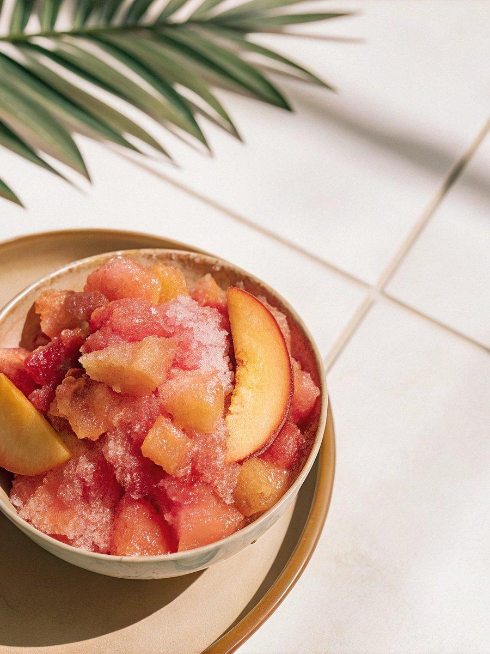

INGREDIENTS  - 4 cups (960ml) finely chopped fruit of your choice (like watermelon, peaches, strawberries, mixed berries, or oranges)  - 1 cup (240ml) water (or combination of water and juice, see note)  - 1/3 cup cane sugar  - Sliced fruit, (for garnish (optional)  - 2 cups (480ml) brewed coffee  - 1/2 cup cane sugar  - Coffee beans, (for garnish (optional) | PREP  COOK  1. Blend and freeze. To make a fruit granita, combine the fruit, water, and sugar into a blender or food processor and blend 30 seconds until smooth. For a coffee granita, mix the brewed coffee with the sugar until the sugar is dissolved. Taste and adjust the sweetness to your liking. Pour the mixture into a rimmed sheet pan or baking dish that’s at least 8X12–inches. Place in the freezer for one hour.  2. Scrape. After an hour, use a metal fork like a rake, scraping through the mixture to break up the ice. Return to the freezer for another 30 minutes to an hour.  3. Repeat. Continue scraping with a fork through the mixture every 30 minutes to an hour until it is fully frozen and the granita has a fluffy granulated texture. This should take about 2 hours in total if you have a large sheet tray, or longer if you’re using a smaller baking dish.  4. Serve or store. Scrape into a pile and scoop into chilled serving glasses to serve immediately, or scrape into an airtight container and return to the freezer until you’re ready to serve.  PLATING

