MANGO TURMERIC LASSI  COOK TIME: 5 min  SOURCE:  #refreshing #healthy #smoothie | 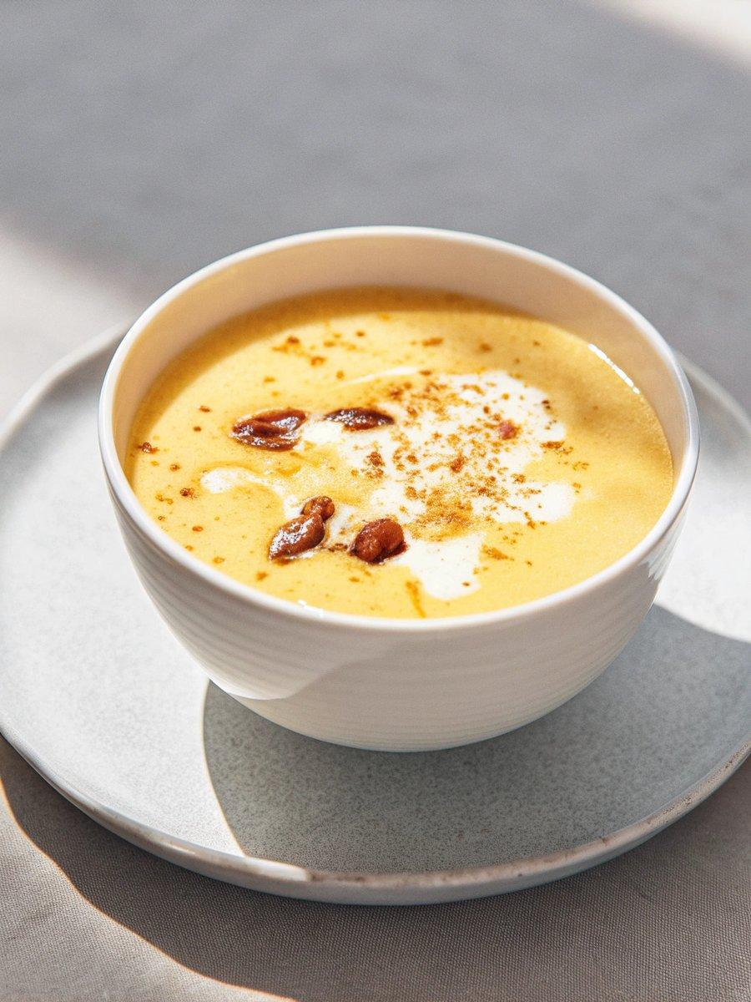

INGREDIENTS  - 2 Medjool date  - 2 1/2 cup frozen mango chunks  - 2 cup (480ml) unsweetened soy yogurt  - 3/4 cup unsweetened soy milk  - 1/2 Tbsp fresh ginger  - 1/2 tsp ground turmeric  - 1 pinch ground black pepper  - 1/4 lemon | PREP  COOK  1. Add all the ingredients to a blender and blend until smooth.  2. Pour into glasses and enjoy!  PLATING

