FUNFETTI ANGEL FOOD CUPCAKES  COOK TIME: 18 min  SOURCE:  #sweet #baking #celebration | 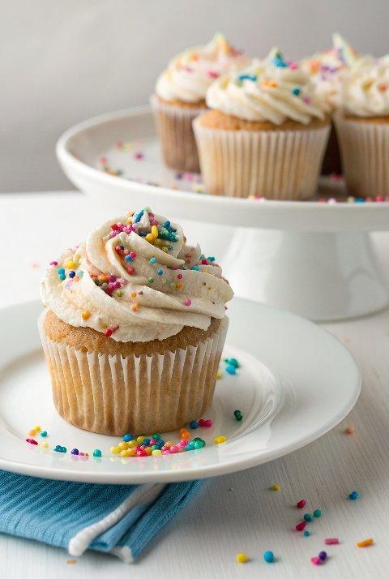

INGREDIENTS  - 3/4 cup + 2 Tbsp (194 g) granulated sugar  - 1/2 cup (68 g) cake flour  - 1/8 tsp salt  - 6 egg whites ((192 g), at room temperature*)  - 2 1/2 Tbsp warm water  - 1/4 tsp vanilla extract  - 1/4 tsp almond extract  - 3/4 tsp cream of tartar  - 3 1/2 Tbsp rainbow jimmies (, roughly chopped)  - Rainbow sprinkles for topping ((more jimmies or nonpareils))  - 1 1/2 cups heavy whipping cream  - 6 oz cream cheese (, softened)  - 1/2 cup + 2 Tbsp powdered sugar  - 1/2 tsp vanilla extract  - 1/2 tsp almond extract | PREP  COOK  1. Preheat oven to 350 degrees. In a food processor, pulse sugar until super fine, about 2 minutes (if you don't have a food processor caster sugar should also work). In a mixing bowl, sift together half of the sugar, the cake flour and the salt.  2. In a large mixing bowl, whisk together egg whites, water, vanilla and almond extract and cream of tartar until well combined, about 2 minutes. Switch to a hand mixer and whip mixture on medium speed while slowly adding remaining sugar to mixture, until medium peaks form.  3. Sift just enough of the flour mixture in to evenly dust the top of the egg white mixture and using a spatula gently fold flour layer into egg white mixture and continue this process until all of the flour mixture has been incorporated (I did this in 12 batches). Fold in chopped sprinkles.  4. Divide batter among paper lined muffin cups, filling each cup nearly full. Bake in preheated oven 19 - 22 minutes until golden and toothpick inserted into center comes out clean.  5. Cool completely then spread Cream Cheese Whipped Cream over cupcakes just before serving and top with rainbow sprinkles.  6. For the Cream Cheese Whipped Cream Topping:  7. In a mixing bowl whip heavy cream until soft peaks form. In a separate mixing bowl, whip cream cheese until light and fluffy. Add cream cheese to whipped cream along with powdered sugar, vanilla extract and almond extract and whip until stiff peaks form. Store in refrigerator.  PLATING

