IRISH SODA BREAD  COOK TIME: 50 min  SOURCE:  #quick #comfort-food #baked | 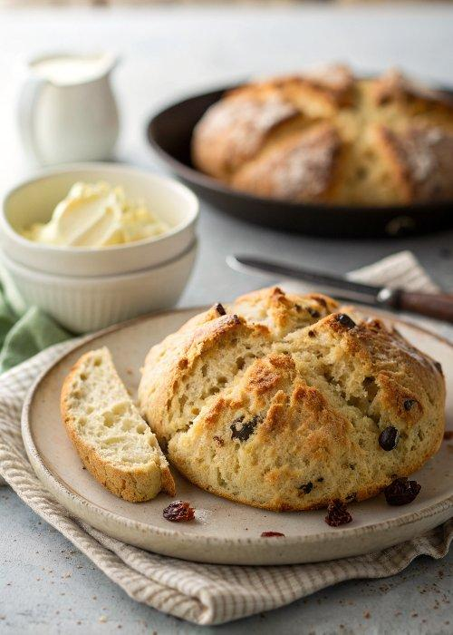

INGREDIENTS  - 5 cups (1200ml) all-purpose flour (700 g)  - 1/2 to 1 cup (240ml) sugar (110-220 g, depending on desired sweetness)  - 1 tbsp baking powder (12 g)  - 1 1/2 tsp salt (7 g)  - 1 tsp baking soda (6 g)  - 1 stick unsalted butter (4 oz or 113 g, softened and cut into cubes)  - 1 1/2 cups raisins (190 g)  - 2 cups (480ml) buttermilk (475 ml)  - 1 large egg | PREP  COOK  1. Preheat your oven to 350°F (175°C).  2. Combine the all-purpose flour, granulated sugar, baking powder, salt and baking soda together in a large bowl.  3. Cut the butter into small ¼ inch cubes and use a pastry cutter or two butter knives to cut the butter into the flour until the mixture resembles coarse crumbs.  4. Stir in the raisins, ensuring that the raisins are coated with flour and are not sticking together in any clumps.  5. Beat together the buttermilk and egg in a medium bowl, and then add to the dry mixture. Stir with a spatula until the wet and dry ingredients are incorporated, but don’t overwork or knead the dough. The dough may be sticky, but that is normal.  6. Transfer your Irish soda bread dough to a floured surface. If you are making two loaves, then cut the dough in half. Shape into one large round loaf or two small ones, and again, don’t work the dough too much.  7. Transfer the loaf (or loaves) to a baking sheet lined with parchment paper. Dip a knife into some flour and then cut a large X across the top of the dough, about 1" deep.  8. Bake at 350°F (175°C) for 50-60 minutes for a single large loaf or 40-50 minutes for two smaller loaves, or until a toothpick inserted into the bread comes out clean.  PLATING

