MOHINGA  COOK TIME: 1h  SOURCE:  #comfort-food #quick #hearty | 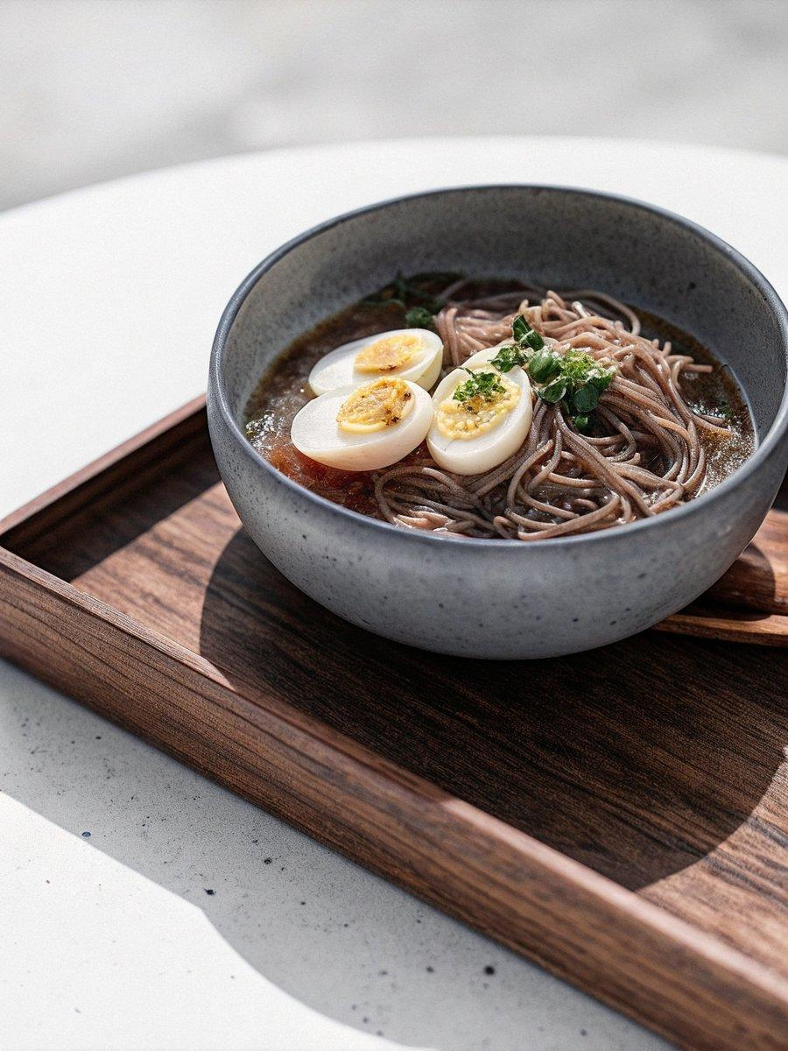

INGREDIENTS  - 2 eggs  - 100 g dried rice vermicelli (0.8–1 mm)  - 1 lime  - chilli flakes, to taste  - handful of coriander (stalks for broth, leaves for garnish)  - 2 x 100 g tins of sardines in sunflower oil  - 1 tbsp paprika  - 1 tbsp turmeric powder  - 3 garlic cloves, peeled  - 15 g fresh ginger, peeled  - 2 lemongrass stalks, trimmed  - 1 medium onion, chopped  - 1/2 tsp chilli powder  - 1 tbsp fish sauce, plus optional extra to taste  - 100 g shallots, peeled  - 1 tbsp rice flour  - 7 tbsp vegetable, sunflower or peanut oil (reserve for reuse)  - 25 g chana dal, soaked overnight and dried  - 2 garlic cloves, finely sliced  - 2 tbsp oil (from the chana dal)  - optional: pinch of turmeric powder | PREP  COOK  1. Prepare the toppings and garnishesBoil the eggs and cool under running water, then peel and halve. Cook the vermicelli according to packet instructions, then rinse under cold water and set aside. Cut the lime into wedges, and pick the coriander leaves, finely chopping and reserving the stalks.  2. Prepare the sardinesTip the sardines into a bowl, including their oil, and mash gently with a spoon. Add ½ a tablespoon each of paprika and turmeric, and mash again, then put aside.  3. Make the crispy chana dalHeat 7 tablespoons of oil in a small pan. Add the soaked and thoroughly dried chana dal and fry for 7–10 minutes until golden and crisp. Remove with a slotted spoon and drain on kitchen paper. Keep the oil for later — it’ll be used for the garlic oil and broth.  4. Make the garlic oilGently fry the garlic slices in the reserved oil until golden. Add a pinch of turmeric (if using), stir, then remove from the heat and set aside.  5. Toast the rice flourPlace a dry frying pan over a medium heat and toast the rice flour for 3–5 minutes, stirring occasionally, until light golden and nutty. Tip onto a plate and set aside  6. Build the brothCrush the garlic and ginger together in a pestle and mortar. Lightly bash the lemongrass to release its aroma.Heat 3 tablespoons of garlic oil in a large pan over a medium heat. Add the chopped onion and cook gently for 5 minutes until soft and translucent. Stir in the crushed garlic and ginger and cook for 1 minute.Add the sardines, ½ a tablespoon each of paprika and turmeric, and the lemongrass. After a few minutes add the chilli powder, followed by the fish sauce, stirring well.Pour in 500ml (2.1 cups) of water and add the shallots and coriander stalks. Bring to the boil, then reduce the heat and simmer for about 20–30 minutes, stirring occasionally.  7. Thicken the brothIn a small bowl, whisk the toasted rice flour with a splash of boiling water until smooth, then stir into the broth. Simmer for a few more minutes to thicken slightly.  8. Taste and finishRemove the lemongrass and adjust the seasoning with more fish sauce, if needed.To serve, divide the noodles between bowls, ladle over the hot broth and top with the boiled eggs, fried chana dal, a drizzle of garlic oil, a squeeze of lime juice, a sprinkle of chilli flakes (to taste) and the coriander leaves.  PLATING

