INSTANT POT VEGAN BOLOGNESE  COOK TIME: 18 min  SOURCE:  #quick #comfort-food #one-pot | 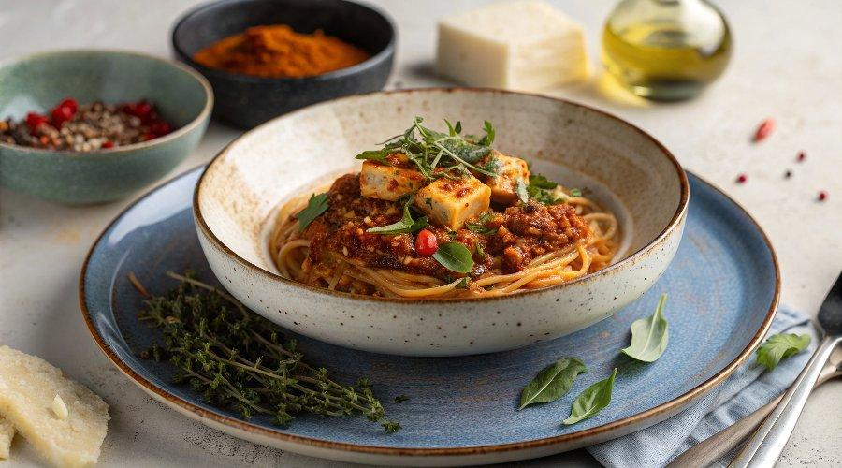

INGREDIENTS  - 1 (16-oz) block of firm tofu  - 2 tbsp olive oil, (divided)  - 1 tsp chili powder  - 1/2 tsp garlic powder  - 1/2 tbsp dried thyme  - 1/2 tbsp dried oregano  - 1/2 tsp black pepper  - 1/2 tsp red pepper flakes  - 1/8 tsp cayenne  - 1 medium onion, (finely chopped)  - 2 celery ribs, (diced)  - 1/2 cup mushrooms, (diced)  - Kosher salt to taste  - 1 )24-oz) jar of marinara sauce (not chunky)  - 32 oz of vegetable broth  - 1 (14-oz) can of diced tomatoes  - 1 lb dried penne pasta (or other medium-sized pasta of choice)  - Garnishes: flat-leaf parsley, minced & vegan parmesan cheese | PREP  COOK  1. Press the tofu for 30 minutes to remove the excess water (see video at 00:37 for instructions).  2. Turn on the Sauté function on the Instant Pot and add 1 tablespoon of the olive oil. Once hot, crumble in the tofu and the seasonings (chili powder, garlic powder, thyme, oregano, black pepper, red pepper flakes, and cayenne). Sauté until tofu begins to brown, approximately 4-6 minutes. Remove tofu from the Instant Pot and set aside.  3. Add 1 more tablespoon olive oil to the Instant Pot and add the diced onion, celery and mushrooms. Cook for 4-5 minutes until softened, adding salt and pepper to season in the last minute of cooking.  4. Return the browned tofu to the Instant Pot. If needed, add a tablespoon of vegetable broth or water to deglaze any browned bits stuck on the bottom of the pot.  5. On top of the tofu and cooked vegetables. Then add the pasta and vegetable broth, pushing the pasta down to make sure it is completely covered in liquid. Gently pour the marinara sauce, and diced tomatoes on top of the pasta but do not stir in (this helps prevent the tomatoes from scorching).  6. Secure the lid of the Instant Pot and select the Pressure Cook setting at high pressure for 5 minutes (see tips above to calculate the precise cooking time based on your pasta box cook time).  7. When the time is up, perform a quick pressure release and open the Instant Pot. Stir the pasta well and serve with vegan parmesan cheese and minced parsley.  PLATING

