POSH FISH & CHIPS  COOK TIME: 52 min  SOURCE:  #comfort-food #quick #seafood | 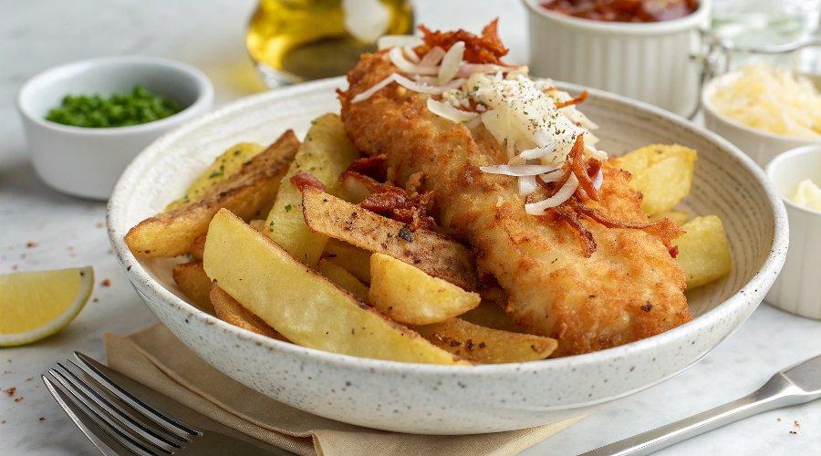

INGREDIENTS  - 500 g potatoes  - olive oil  - 1 free-range egg  - 1/2 tsp smoked paprika  - 10 g Parmesan cheese  - 1 thick slice of seeded wholemeal bread (40 g)  - 2 x 130 g salmon fillets, skin off, scaled, pin-boned, from sustainable sources  - 1 tbsp plain flour  - 1 x 340 g jar of baby cornichons  - 160 g frozen peas  - 2 sprigs of mint | PREP  COOK  1. Scrub the potatoes, chop lengthways into 2cm (1-inch) wedges, place in the large air-fryer drawer, toss with 1 tablespoon of olive oil and a pinch of sea salt and black pepper and arrange in a single layer. Cook for 30 minutes at 200ºC, or until golden and cooked through, shaking halfway.  2. Beat the egg, paprika and a little seasoning in a shallow bowl. Finely grate the Parmesan into a food processor, tear in the bread, add 1 tablespoon of oil and blitz into fine crumbs, then spread across a plate.  3. Dust the salmon with the flour, then dip into the egg mixture, letting any excess drip off. Coat in the breadcrumbs, spending a bit of time really patting them on. Evenly space in the small drawer and cook for 10 minutes at 200ºC, or until golden and just cooked through.  4. Meanwhile, to make a gherkin ketchup, empty the jar of cornichons, and half their juice, into the food processor and blitz until smooth. Spoon out two portions, then pour the rest back into the jar and pop it in the fridge for future meals, where it will keep happily for up to 2 weeks.  5. Cook the peas for 4 minutes in boiling salted water, then drain, reserving a little cooking water. Tip them into the food processor (there’s no need to clean it), pick in the mint leaves and blitz, loosening with splashes of reserved water, if needed, then season to perfection and cover to keep warm.  6. Serve up the fish and chips with the minty peas and gherkin ketchup.  PLATING

