HOMEMADE STRAWBERRY SAUCE (TOPPING)  COOK TIME: 8 min  SOURCE:  #quick #fresh #sweet | 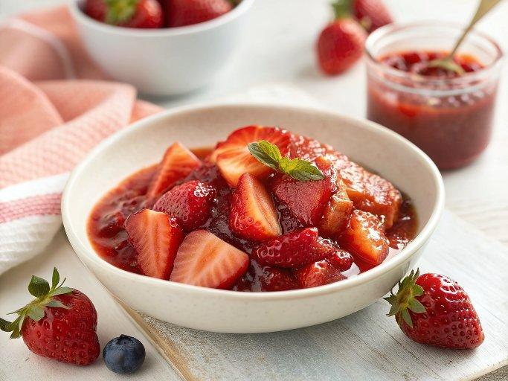

INGREDIENTS  - 1 tbsp cornstarch  - 3 tbsp (45 ml) warm water  - 1 lb strawberries, hulled and sliced in half (you can use frozen; don’t thaw)  - zest and juice from 1/2 small lemon (see note)*  - 1/4 cup (50 g) granulated sugar | PREP  COOK  1. Whisk the cornstarch and water together until all the cornstarch has dissolved. (I just use a fork to mix—very easy.)  2. Place the cornstarch mixture, along with the rest of the ingredients, into a small saucepan over medium heat. Using a wooden spoon or rubber spatula, stir the mixture as it cooks. Break up some of the strawberries as you stir.  3. Bring it to a simmer and allow to simmer for 5 minutes, stirring constantly. After 5 minutes, remove pan from the heat and allow to cool. The mixture will thicken as it cools.  4. You can serve the sauce warm before it cools completely if desired, or store in the refrigerator for up to 1 week. Strawberry topping will be thick after refrigeration, so microwave for 15 seconds or warm on the stove to thin out, if desired.  PLATING

