TACO STACK  COOK TIME: 20 min  SOURCE:  #quick #comfort-food #taco | 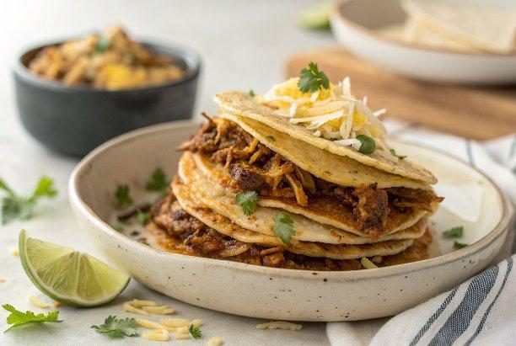

INGREDIENTS  - 8 small tortillas (, corn or flour (around 6" / 12 cm rounds)  - 3 cups (720ml) shredded Pork Carnitas or Quick Mexican Chicken (see below)  - 1 tbsp olive oil  - 1 1/2 cups grated cheese (I used Monterey Jack. See Note 1 for other suggestions)  - 1 1/4 cups corn kernels (, fresh, frozen or canned (drained) (I used frozen)  - 1 tbsp olive oil  - 1 punnet cherry tomatoes (, diced (or 2 medium tomatos, deseeded and diced, around 1 1/2 cups (Note 2))  - 2 shallots / scallions (, green part only, sliced)  - 1/2 lime (, juice only (add more or less to taste)  - Salt and pepper to taste  - 1.2 lb / 600 g chicken thigh fillets (, skinless and boneless, cut into 1 cm / 2/5" slices (Note 3)  - 1 tsp garlic powder (or add 1 minced garlic clove into the oil in the fry pan)  - 2 tsp cumin powder  - 1 tsp paprika  - 1/2 tsp oregano  - Pinch of cayenne or chili powder (for heat - adjust to taste)  - 1 1/2 tsp salt  - Black pepper  - 1 lime (, juice only)  - 1 tbsp olive oil  - Sour cream  - Cilantro / coriander  - Jalapeños (, finely chopped)  - Avocado (, diced) | PREP  COOK  1. Preheat oven to 180C/350F.  2. Prepare either the Pork Carnitas or Quick Mexican Chicken.  3. Place the corn tortillas in the oven (I do it directly on the shelf) and bake for 3 to 5 minutes on each side, just to make them a bit stiff but not browned.  4. Place a tortilla on a baking tray. Scatter 1/6th of the Pork Carnitas or Quick Mexican Chicken on the tortilla and top with Salsa (reserve some for Topping) then cheese. Place another tortilla on top and repeat, then again (so you end up with 3 layers of meat. Place the 4th tortilla on top. I don't put anything on it, but you could sprinkle some cheese if you want.  5. Repeat with remaining 4 tortillas.  6. Bake for 10 minutes until heated through and cheese is melted (it does not take long).  7. Remove from oven.  8. Top with remaining Salsa and Toppings of choice (I used sour cream, avocado, jalapeño and coriander/cilantro)  9. Salsa  1  0. Heat 1 tbsp olive oil in a large pan over high heat. Add the corn and sauté for a couple of minutes until charred to your liking. (This step is optional)  1  1. Allow to cool slightly, then toss with remaining Salsa ingredients.  1  2. Pork Carnitas  1  3. Defrost (if using frozen), then heat 1 tbsp olive oil in a large fry pan over high heat.  1  4. Add Pork Carnitas and cooking until the underside is golden brown (do not flip - Note 4).  1  5. Remove from pan (scrape up all the brown bits) and set aside.  1  6. Quick Mexican Chicken  1  7. Combine all ingredients other than the oil in a bowl and toss to combine.  1  8. Heat the oil in a large fry pan over high heat.  1  9. Add the chicken and sauté until browned and cooked through.  2  0. Remove chicken from the fry pan. Allow to cool then either roughly chop into smaller pieces or use a fork to "shred".  PLATING

