MASALA DOSA  COOK TIME: 45 min  SOURCE:  #traditional #comfort-food #savory | 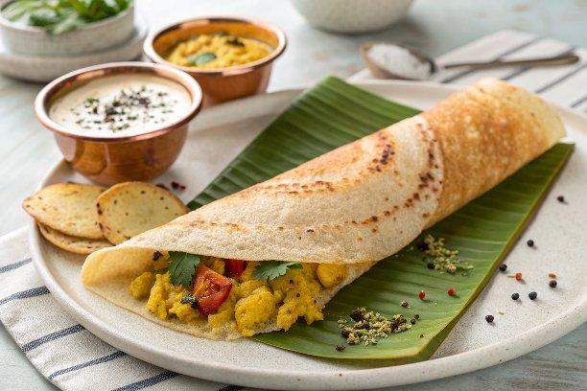

INGREDIENTS  - 300 g white rice  - 100 g split urad dal  - 10 g fenugreek seeds  - neutral-tasting oil (such as sunflower), for drizzling | PREP  COOK  1. Tip the rice into a large bowl and cover with 500ml (2.1 cups) water. Combine the urad dal and fenugreek seeds in a second bowl, then pour over 400ml (1.7 cups) water. Cover both bowls and leave to soak overnight.  2. The next morning, pour the soaked rice and its water into a food processor. Blitz for 1 min until a thick paste forms – you can add a little extra water, if needed. The rice mixture may be thinner in texture and more glue-like. Tip into a bowl and repeat with the urad dal mixture. Pour this into the rice mixture and combine. Cover and leave in a warm part of the kitchen to ferment for 24 hrs. You will find that the batter rises a little, smells sour and has bubbles on top. At that point, transfer it to the fridge until you are ready to cook.  3. Check the batter is the right consistency – it should be easy to spread, like crêpe batter, so add a little more water, if needed. Heat a few drops of oil in a large, non-stick frying pan over a medium heat and carefully wipe the oil around the pan using kitchen paper. Pour a ladle of batter into the pan and use the bottom of the ladle to spread it over the base, making a large, thin dosa. Drizzle 1 tsp oil around the edge of the dosa and turn up the heat. Cook until it turns golden and releases from the pan. Fold the dosa in half and remove from the pan. Repeat with the remaining batter.  PLATING

