ROASTED CAULIFLOWER CHEESE FILO PIE  COOK TIME: 1h 20m  SOURCE:  #comfort-food #baked #cheesy | 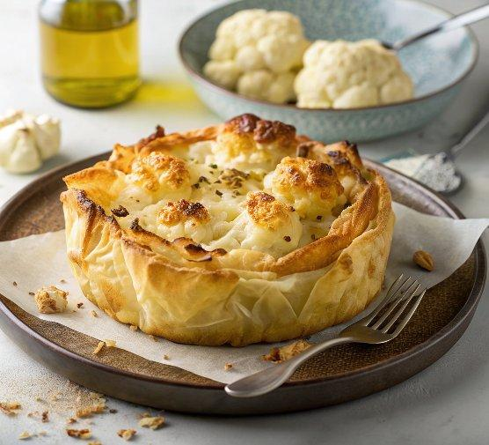

INGREDIENTS  - 1 head of cauliflower leaves and stalk cut into small pieces, then cut into florets  - 2 tbsp olive oil  - 40 g parmesan or vegetarian Italian-style cheese  - 100 g melted butter or olive oil, for brushing the pastry and the tin  - 4 sheets of filo pastry  - 50 g butter  - 40 g plain flour  - 500ml (2.1 cups) whole milk  - 1 tsp mustard powder or English mustard  - 150 g extra mature cheddar grated  - grating of nutmeg  - pinch of cayenne pepper | PREP  COOK  1. Heat the oven to 210C/190C fan/gas  7. Tip the cauliflower florets and chopped leaves and stalks on a roasting tray and toss with the olive oil and a pinch of salt. Grate over about a quarter of the parmesan. Roast for 30 mins until lightly charred and tender. Set aside.  2. While the cauliflower is roasting, prepare the cheese sauce. Melt the butter in a saucepan over medium heat until frothy. Stir in the flour and cook for 2-3 mins to form a sandy paste. Gradually whisk in the milk, stirring constantly to avoid lumps. Once all the milk is incorporated, cook for 10 mins, stirring occasionally, until the sauce thickens. Add the mustard powder and all but a handful of the grated cheddar. Stir until smooth. Season with the nutmeg and cayenne, and some salt to taste.  3. Butter or oil a round spring form cake tin. Lay a sheet of filo pastry inside the dish, letting the edges overhang. Brush the filo with more butter or oil and scatter with a bit of parmesan and repeat with the rest of the sheets working your way around and overlapping them to cover the base and sides.  4. Tip the roasted cauliflower into the centre of the filo-lined dish. Pour the cheese sauce over the cauliflower, ensuring it’s evenly coated. Ruffle up the overhanging filo sheets around the filling and scrunch it slightly to create a decorative finish. Brush with more melted butter or oil. Scatter the exposed sauce with the remaining cheddar and sprinkle with the rest of the parmesan. Bake for 20 mins then remove the tin but leave the base underneath it, and bake for a further 20 mins until the pastry is golden and crisp. Leave to cool slightly before serving.  PLATING

