PUMPKIN MOUSSE PARFAIT  COOK TIME: 30 min  SOURCE:  #quick #comfort-food #no-bake | 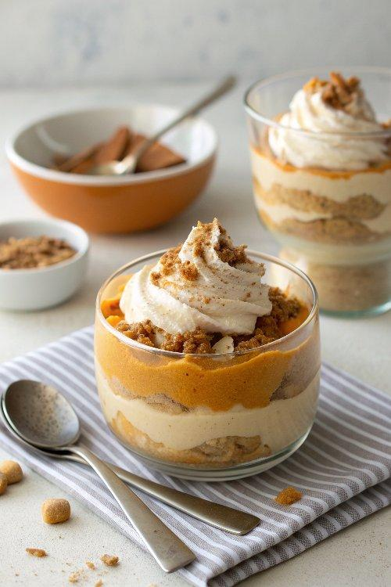

INGREDIENTS  - 2 cups (480ml) cold heavy cream or heavy whipping cream (480 ml)  - 4 tbsp powdered sugar (30 g)  - 1 1/2 tsp pure vanilla extract  - 8 oz block cream cheese, at room temperature (227 g)  - 1 cup (240ml) pumpkin puree (227 g)  - 1/3 cup brown sugar (70 g)  - 1 1/2 cups crushed gingersnaps, for layering (128 g)  - 4-oz white chocolate bar, for garnish (113 g) | PREP  COOK  1. Chill the cream: Cream whips best when it’s very cold. If your cream isn’t cold, chill it in the refrigerator before starting.  2. Whip the cream: In a large mixing bowl (or stand mixer), beat the cream on low speed until it foams and bubbles. Gradually increase to medium-high. Once slightly thickened, add the powdered sugar, and vanilla. Continue beating on high until medium peaks form (the cream should be thick but still softly fall back onto itself). Refrigerate until needed.  3. Make the pumpkin mousse: In another bowl, beat the pumpkin puree, pumpkin pie spice, cream cheese, and the brown sugar until smooth and creamy. Taste and adjust the sweetness if needed.  4. Fold in cream: Gently fold half of the whipped cream into the pumpkin mixture until combined.  5. Assemble the parfaits: Set out 6 cups (1440ml) or jars. Start with a layer of crushed gingersnaps, followed by pumpkin filling, then a layer of whipped cream. Repeat, finishing with whipped cream on top. Garnish with extra gingersnaps or a piece of white chocolate.  PLATING

