THAI CHILI SAUCE CHICKEN STIR-FRY  COOK TIME: 5 min  SOURCE:  #quick #stir-fry #spicy | 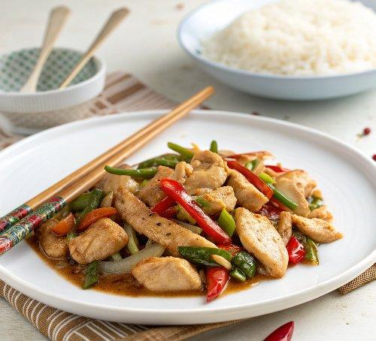

INGREDIENTS  - 1 1/2 lb chicken breast (680 g, sliced into 1/4-inch thick pieces)  - 1 tbsp cornstarch  - 3 tbsp oil (divided)  - 3 cloves garlic (thinly sliced)  - 2 Thai bird chilies (thinly sliced, optional)  - 1 red bell pepper (de-seeded and thinly sliced)  - 5 scallions (sliced at an angle into 2-inch pieces)  - 2 tbsp Thai Chili Paste (Namprik Pao)  - 1 tbsp fish sauce | PREP  COOK  1. Add the chicken to a bowl, along with the 1 tablespoon cornstarch and 1 tablespoon oil. Mix well and set aside.  2. Heat a wok over high heat until smoking. Add 2 tablespoons of oil, and the chicken. Stir-fry the chicken for 1-2 minutes, until well-seared.  3. Add the garlic, chilies (if using), bell pepper, scallions, chili sauce, and fish sauce. Stir-fry for another 2 minutes.  4. Serve with steamed jasmine rice.  PLATING

