MAGIC GOOEY CHOCOLATE MERINGUE TEXAS SHEET CAKE.  COOK TIME: 40 min  SOURCE:  #chocolate #cake #comfort-food | 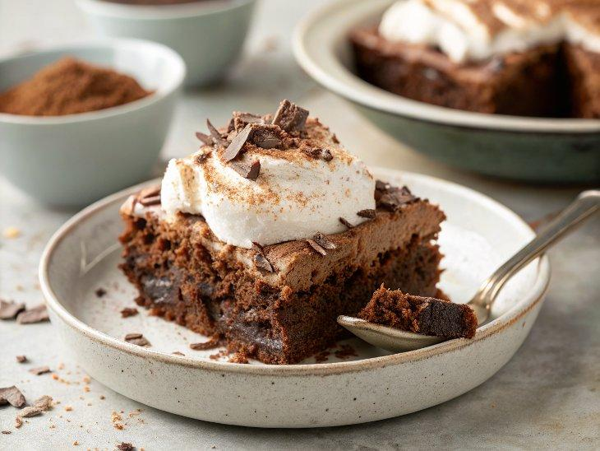

INGREDIENTS  - 1 cup (240ml) unsalted butter (2 sticks)  - 2 tbsp unsweetened cocoa powder  - 1 cup (240ml) brewed coffee  - 2 cups (480ml) all-purpose flour  - 1 1/3 cups granulated sugar  - 1 tsp baking soda  - 1/2 tsp salt  - 2 eggs  - 1 tsp vanilla extract  - 1/2 cup plain greek yogurt  - 2 1/4 cups sweetened condensed milk cans)  - 4 oz dark chocolate (chopped)  - 6 egg whites  - 3/4 cup + 2 tbsp superfine sugar  - 1 1/2 tsp white vinegar  - 3 tsp corn starch  - 1 1/2 tbsp unsweetened cocoa powder  - 1/2 cup dark chocolate (melted)  - powdered sugar (for dusting) | PREP  COOK  1. Preheat the oven to 350°F (175°C). Grease a 10x15-inch (25x38cm) high sided baking dish. I used a 10x15-inch (25x38cm) pyrex pan, but a lasagna baker would work too.  2. To make the cake, place the butter, cocoa powder and coffee in a medium size sauce pot. Melt the butter over medium heat until the mixture is smooth and combined. Remove from the heat and add the flour, sugar, baking soda and salt. Whisk until just combined, it is ok if some flour chunks remain. Whisk in the eggs, vanilla and greek yogurt until just combined and smooth. Again, it is ok if the batter is a little lumpy.  3. Pour the batter into the greased baking dish. Bake for 20 minutes or until just set on top. Remove from the oven.  4. While the cake is baking, make the gooey chocolate. Combine the sweetened condensed milk and chopped dark chocolate in a small sauce pan and slowly melt the chocolate into the sweetened condensed milk over low heat until melted and smooth. Keep warm.  5. Once the cake is out of the oven pour the gooey chocolate over the cake, spreading it out in an even layer.  6. To make the meringue. Add the egg whites to a clean mixer bowl. Using a clean whisk attachment, beat on high speed until you have soft peaks. With mixer running, slowly add sugar. Once all the sugar has been added, add the vinegar. Continue beating until stiff peaks form, about 4 minutes. Gently fold in the corn starch and cocoa powder being careful not to deflate the whites. Drizzle the melted chocolate over the meringue. Do not stir the melted chocolate completely into the meringue as you want streaks of chocolate.  7. Carefully spread the meringue over the cake. Bake for 15-20 minutes or until the meringue is just set on top. Remove the cake and allow to cool 1 hour. Cut and dust with powdered sugar before serving. This can be served slightly warm, at room temp or straight from the fridge. We loved it slightly warm!  PLATING

