HAM AND CHEESE SANDWICHES WITH BACON, PINEAPPLE CARAMELIZED ONIONS + JERK BBQ SAUCE.  COOK TIME: 40 min  SOURCE:  #comfort-food #sandwich #quick | 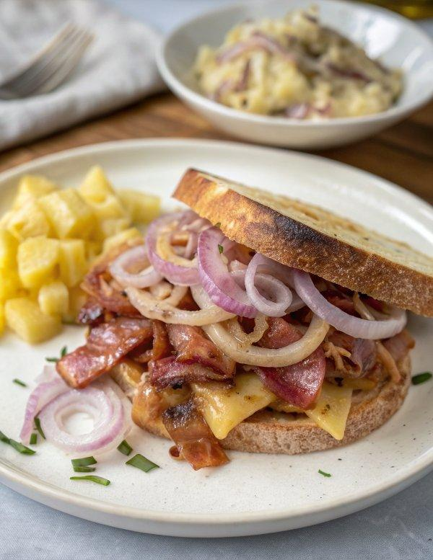

INGREDIENTS  - 1 large onion (thinly sliced)  - 2 sweet onions (sliced thin)  - 8 tbsp butter (divided)  - 1 cup (240ml) pineapple juice  - 1 cup (240ml) pineapple (diced)  - 2 tsp dijon mustard  - 1 tsp worcestershire  - 12 rolls (I used slider size)  - 12 slices leftover ham  - 12 slices of swiss cheese  - 6-8 slices fried bacon  - 1 tsp poppy seeds  - 1 cup (240ml) of your favorite BBQ Sauce  - 1/3 cup pineapple juice  - 1 tbsp soy sauce  - 1-2 tsp spicy curry powder (depending on your taste)  - 1/4 tsp cinnamon  - 1 jalapeno (seeded + chopped) | PREP  COOK  1. To make the BBQ sauce, combine the BBQ sauce, pineapple juice, soy sauce, spicy curry powder, cinnamon and jalapeno, mix well and keep in the fridge until ready to use or up to two weeks.  2. Heat a large skillet over medium-high heat and add 1 tablespoon butter. Add the onions and cook about 10 minutes, stirring frequently, until softened. At this point you want to slowly add the pineapple chunks and the pineapple juice, a little at a time, letting everything cook into the onions, slowly adding more until until you have added all the pineapple chunks and juice. Cook until the onions are caramelized to your liking and the pineapple juice has evaporated. Remove from the heat.  3. Melt the remaining butter over the stove and then whisk in the mustard and worcestershire,  4. Line a cookie sheet or 9x13-inch (23x33cm) baking dish with tin foil. Place the bottom half of the rolls on the foil and brush each half with the melted butter. Add the ham, if desired drizzle the BBQ sauce over the ham. Now add the onions and then the swiss cheese and bacon. Place the top half of the rolls over the cheese. Brush the tops of the rolls with butter and sprinkle with poppy seeds. Now place another piece of foil over the sandwiches and seal the two pieces of foil together.  5. Bake for 15-20 minutes or until the cheese is melted. Remove the foil and serve warm with BBQ sauce for dipping.  PLATING

