KOREAN TOFU WITH SPICY KOREAN KETCHUP  COOK TIME: 15 min  SOURCE:  #quick #spicy #tofu | 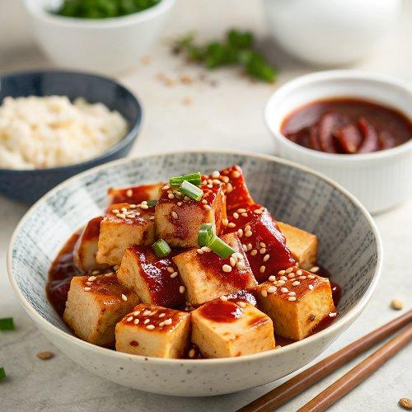

INGREDIENTS  - 250 g tofu (0.6 lb), firm to extra firm, cut into cubes)  - cooking oil (, I used rice bran oil)  - 3 Tbsp ketchup  - 1 -1.5 Tbsp gochujang  - 1/2 Tbsp soy sauce (, regular)  - 1/2 Tbsp honey (or maple syrup)  - 1 tsp sesame oil  - 1 tsp minced garlic  - toasted sesame seeds (optional)  - green onions (, finely chopped (optional) | PREP  COOK  1. Combine the spicy Korean ketchup sauce ingredients in a bowl. Mix them well and set it aside.  2. Pat dry the cubed tofu using kitchen paper. You may also want to gently press them down to squeeze more water out. Pan fry the tofu in a skillet over medium high heat until all sides are golden brown. (It will take 2-3 mins on each side.) Remove the tofu from the skillet and set it aside.  3. Pour in the spicy ketchup sauce in the skillet and stir it over medium low heat for about 5 to 10 seconds. Return the tofu to the skillet. Gently coat with the sauce. Sprinkle with sesame seeds and green onions.  4. Serve with steamed rice. (It can be served warm or cold.)  PLATING

