EASY PINEAPPLE CHERRY DUMP CAKE  COOK TIME: 55 min  SOURCE:  #quick #comfort-food #baking | 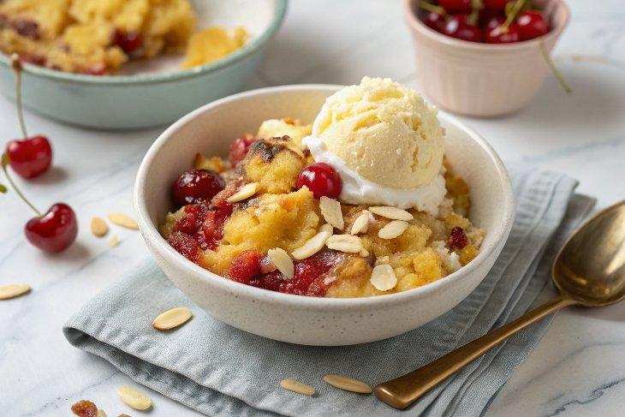

INGREDIENTS  - 20 oz crushed pineapple (undrained (we used Dole)  - 21 oz cherry pie filling (we used Duncan Hines)  - 1 pkg moist yellow cake mix (we used Betty Crocker)  - 1/2 - 1 cup (240ml) shaved almonds or chopped walnuts  - 1/2 cup 1 stick butter, melted | PREP  COOK  1. Preheat oven to 350˚. Butter bottom and sides of a 9x13-inch (23x33cm) baking pan.  2. Dump pineapple with juice and spread into bottom of pan. Top with cherry pie filling.  3. Sprinkle the top evenly with dry cake mix, add nuts if using then drizzle the top with melted butter. Bake uncovered at 350˚F for 55-60 min or until bubbly and browned.  PLATING

