NUTELLA STUFFED PANCAKES  COOK TIME: 20 min  SOURCE:  #quick #comfort-food #sweet | 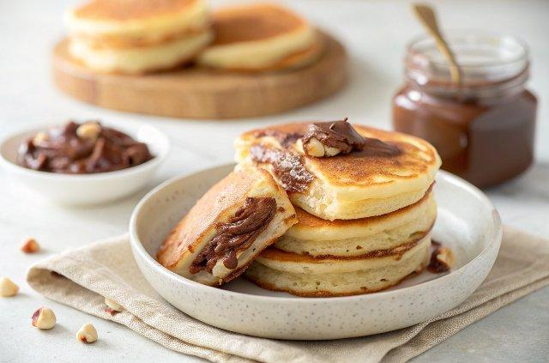

INGREDIENTS  - 10 - 14 tbsp Nutella  - 1 1/2 cups plain flour  - 3 tsp baking powder  - 4 tbsp sugar  - Pinch of salt  - 1 egg  - 1 cup (240ml) + 2 tbsp milk (I used low fat)  - 1 tsp vanilla essence (optional)  - 1 tsp butter (, separated (2 x 1/2 tsp)  - Sliced strawberries (optional) | PREP  COOK  1. Frozen Nutella Disc  2. Line a baking tray with baking paper (parchment paper).  3. Dollop 1 1/2 to 2 tbsp of Nutella onto the baking tray and spread into a disc around 2 1/2" / 6cm (2-inch) in diameter and 1/5" / 1/2cm (1-inch) thick. (Note 1) Repeat to make 7 discs.  4. Place the tray in the freezer until firm (around 1 to 1 1/2 hours).  5. Peel off the parchment paper. Keep the Nutella discs in the freezer until required (they soften quickly).  6. Pancakes  7. Place the Dry Ingredients in a bowl and whisk to combine.  8. Make a well in the centre and place the Wet Ingredients in the well. Whisk until combined and lump free (stop whisking as soon as it is smooth, don't over whisk).  9. Melt 1/2 tsp butter in a non stick fry pan over medium heat. Once melted, wipe most of the butter off with a paper towel. (Note 2)  1  0. Take 3 Frozen Nutella Discs out of the freezer just before you start cooking. (Note 3)  1  1. Dollop 1/4 cup of batter into the fry pan. Working quickly, place 1 Frozen Nutella Disc in the middle of the batter, then top with batter to cover the Nutella disc (Note 4).  1  2. When bubbles start appearing around the edges (around 2 minutes), lift up the edge and make sure the underside is golden. Then flip and cook until the other side is golden.  1  3. Repeat with remaining batter. Melt more butter in the pan after the 3rd or 4th pancake. You should be able to make 7 in total, but sometimes it makes 6 - depends on how much batter you use on top of the Nutella.  1  4. Serve warm with sliced strawberries, if using. You could also serve with cream but I find that it's not necessary!  PLATING

