LEMON PASTA  COOK TIME: 10 min  SOURCE:  #quick #comfort-food #pasta | 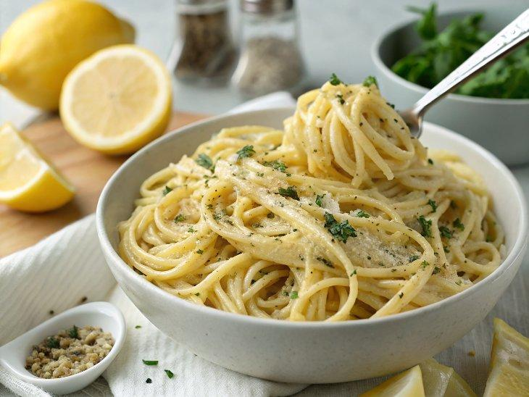

INGREDIENTS  - 8 oz pasta (dry) of choice)  - 1 tbsp olive oil (or veggie broth (if oil-free)  - 1/2 onion (diced)  - 3 cloves garlic (minced)  - 1 tsp lemon zest  - 1 tbsp lemon juice  - Salt & black pepper (to taste)  - 1 Pinch of nutmeg  - 1 1/3 cup plant-based milk (*see notes)  - 2 tbsp cashew butter (*see notes)  - 1 tbsp cornstarch (+ 2 tbsp water (*see notes)  - 2 cups (480ml) baby spinach  - Red pepper flakes (to taste (optional)  - Vegan Parmesan (to garnish (optional) | PREP  COOK  1. You can watch the video in the post for visual instructions.Cook your favorite pasta (regular pasta, gluten-free pasta, or grain-free pasta) in a pot according to package directions.  2. Meanwhile, heat olive oil in a large skillet and add the onion. Sauté for 3 minutes, then add garlic and lemon zest. Sauté for a further minute, stirring frequently.  3. Add lemon juice, salt, nutmeg, black pepper, plant-based milk, and cashew butter. Stir to combine and bring to a boil.  4. In a small bowl combine cornstarch and water. Stir until there are no lumps and pour the mixture into the skillet.  5. Let simmer for a few minutes until thickened, then add spinach, and cook until wilted, about one minute. Turn off the heat and add the cooked pasta. Stir to combine.  6. Taste it and adjust seasonings. Add more salt/pepper/lemon juice or red pepper flakes to taste. Add a splash of plant-based milk or vegetable broth for a thinner sauce.  7. Sprinkle with vegan Parmesan and enjoy!  PLATING

