LEMON OREGANO ROASTED TURKEY  COOK TIME: 2h 20m  SOURCE:  #roasted #comfort-food #holiday | 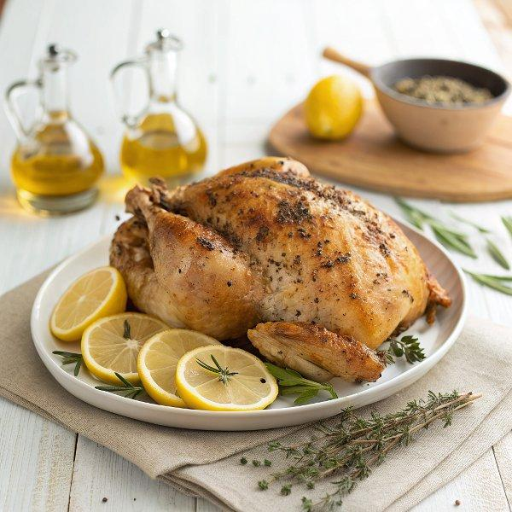

INGREDIENTS  - 3 garlic cloves, (minced)  - 3 tbsp extra virgin olive oil  - 3 lemons  - 2 tbsp kosher salt  - 2 tbsp dried oregano  - 1 tbsp ground fennel  - 1 tbsp dried thyme  - 2 tsp sugar  - 2 tsp freshly ground black pepper  - 1 (12-14 lb) turkey  - 1 yellow onion, (quartered) | PREP  COOK  1. Prepare the rub: In a small bowl. Combine minced garlic, olive oil, salt, zest from 2 lemons, 3 tablespoons of lemon juice from 1 of the zested lemons, oregano, fennel, thyme, sugar, and black pepper. Quarter the other lemons and set aside. You’ll use them to stuff the cavity of the turkey later.  2. Dry-brine the turkey: Remove the neck and giblets from the bird and discard or use to make gravy. Pat the turkey dry inside and out with paper towels. Place the turkey on a platter or rimmed baking sheet large enough to hold the bird but small enough to fit in your refrigerator. Gently lift the skin up from the breasts and use your fingers to separate the skin from the breast meat and leg meat. Massage the rub into the meat under the skin, on top of the skin, and inside the cavity of the turkey.  3. Refrigerate: Wrap the turkey in plastic wrap and store it in the refrigerator for at least 24 hours and up to 48 hours. The salt in the rub penetrates the meat and keeps it juicy.  4. Heat the oven: Position a rack in the bottom third of the oven. Preheat the oven to 425°F (220°C).  5. Prepare the turkey: Remove and discard the plastic wrap. Set the turkey breast side up on a roasting rack set in a roasting pan. Place the quartered lemons and quartered onion inside the cavity of the bird. Use butcher’s twine to truss the Turkey or tie the legs together and tuck the wings under the body so they don’t burn. Season skin with an additional sprinkle of salt and pepper.  6. Roast the turkey: Place the turkey in the hot oven and roast for 20-30 minutes. The skin will start to turn golden brown. Reduce the heat to 350°F (175°C) and cook for an additional 60 minutes.  7. Rotate, baste, and cover the turkey: All ovens are different. It’s best to rotate the pan 180 degrees to ensure even cooking. Use a baster to draw up any fluids from the bottom of the pan and squeeze it over the breast. Tent the breast with foil to prevent overcooking it. Roast for another 60 minutes. The turkey is ready when an instant-read thermometer inserted into the thickest part of the thigh reads 160°F (70°C).  8. Remove the turkey and let it rest: Remove the turkey from the oven, and let it rest for 15 to 20 minutes. The temperature should rise to 165°F (75°C) through carryover cooking.  9. Serve: Carve and serve on a platter decorated with sliced lemons and herbs then with your favorite sides.  PLATING

