CHINESE GROUND CHICKEN BOWL  COOK TIME: 10 min  SOURCE:  #quick #comfort-food #stir-fry | 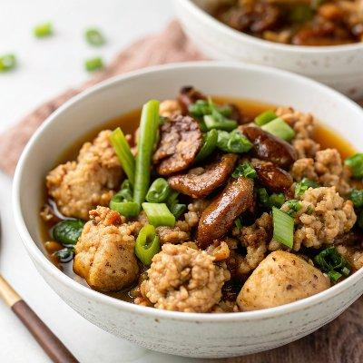

INGREDIENTS  - 8 (20 g) dried shiitake mushroom  - 1 cup (240ml) chicken broth  - 2 tbsp light soy sauce  - 1 tbsp Shaoxing wine  - 1 tsp dark soy sauce  - 2 tsp sugar  - 1/4 tsp Chinese five spice powder  - 1 tbsp peanut oil (or vegetable oil)  - 1/2 thumb ginger , minced  - 2 cloves garlic , minced  - 1 lb (450 g) ground chicken (or ground pork or ground beef)  - 2 tsp cornstarch  - 2 tbsp water  - 1 tsp sesame oil  - Steamed rice (or noodles)  - Sliced green onion (for garnish)  - Fried eggs (or marinated eggs)  - Steamed vegetables | PREP  COOK  1. Add shiitake mushrooms to a medium-sized bowl and hot water to cover. Let rehydrate until tender throughout, 15 minutes or so. Drain and rinse with running tap water to remove any debris. Squeeze out excess water. Remove and discard the tough stem, and mince the mushrooms.  2. In a small bowl, combine chicken broth, light soy sauce, Shaoxing wine, dark soy sauce, sugar, five spice powder and salt. Mix well and set aside.  3. Heat oil in a large skillet over medium-high heat until hot. Add ginger and garlic. Stir a few times until fragrant.  4. Add ground chicken. Spread out the chicken and let sear without moving for 2 minutes or so. Then stir and chop the ground meat into small pieces. Stir and cook until the chicken is cooked through.  5. Add minced shiitake mushrooms to the skillet. Stir and cook for 1 minute.  6. Pour in the mixed sauce from step 1 and mix well. Simmer until the sauce is mostly absorbed, 5 minutes or so.  7. Mix the cornstarch and water in a small bowl and stir to dissolve completely. Pour into the pan. Stir immediately to thicken the sauce.  8. Drizzle with sesame oil. Taste the chicken and adjust seasoning by adding a pinch of salt if needed.  9. Serve warm over steamed rice or noodles, with steamed vegetables and an egg, if using. Garnish with green onions. Serve as a main dish.  PLATING

