ALBÓNDIGAS (SPANISH MEATBALLS)  COOK TIME: 45 min  SOURCE:  #comfort-food #hearty #meat | 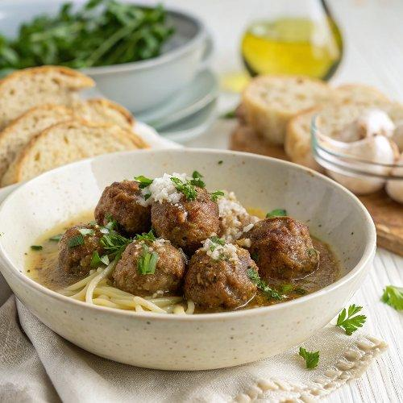

INGREDIENTS  - 3 slices white bread (about 2 oz), crusts removed)  - 1/2 cup milk  - 1 1/2 lb ground beef (85% to 90% lean preferred)  - 1 yellow onion, (grated)  - 2 garlic cloves, (minced)  - 1 large egg  - 1/4 cup chopped fresh parsley  - 1 tsp kosher salt  - Freshly ground black pepper  - All purpose flour, (for coating)  - 1/4 cup extra virgin olive oil  - 1 yellow onion, (finely chopped)  - 4 garlic cloves, (minced)  - 1 cup (240ml) canned crushed tomatoes (or grated fresh tomatoes)  - 1/2 tsp salt  - 1/4 cup fresh parsley  - 1 tbsp roasted unsalted almonds (about 10 to 12)  - 1 pinch saffron (12 to 15 threads)  - 1/2 cup white wine  - 1 cup (240ml) chicken stock | PREP  COOK  1. Soak the bread. Tear the bread into small pieces into a large mixing bowl. Pour the milk over the bread and let it soak for 5 minutes, then give the mixture a stir to form a paste.  2. Make the meatball mixture. To the bowl with the bread mixture, add the beef, onion and its juice, garlic, egg, parsley, salt, and a generous grind of black pepper. Gently mix by hand until everything is combined. The mixture will be soft.  3. Roll the meatballs. Portion the meatballs with a 1-ounce cookie scoop, or 2 tablespoons. Roll them in the palms of your hands to shape them into balls about the size of a golf ball. Place each meatball on a baking sheet and repeat with the remaining mixture, making about 28 meatballs.  4. Sprinkle the flour over the meatballs and roll them to coat. This helps prevent them from sticking and falling apart while frying.  5. Fry the meatballs. Heat the olive oil in a large skillet over medium-high heat. Line a large plate with paper towels and set near your stove. Once the oil is hot, add half the meatballs and cook, turning occasionally, until browned all over, about 10 minutes. Drain the seared meatballs on the paper towel-lined plate. Repeat with the remaining meatballs.  6. Drain the pan. Carefully discard all but 2 tablespoons of the fat from the pan. Keep any browned bits stuck to the pan to add flavor to the sauce, but remove any larger black pieces. Return the pan to medium-high heat.  7. Make the sofrito. Add the onions and sauté until softened and beginning to caramelize, about 5 minutes. Add the garlic and sauté just until softened, about 1 minute. Pour in the tomato and salt and cook until the tomato reduces and the pan is almost dry, about 5 minutes.  8. Make the picada. While the tomato reduces, make the picada. Pulse the parsley, almonds, and saffron in a food processor with the blade attachment until very finely chopped, but not quite a paste.  9. Finish the sauce. Pour the wine and chicken stock into the sofrito and stir to combine. Nestle in the meatballs in a single layer. Sprinkle the picada into the sauce and gently swirl the pan to mix slightly. Reduce the heat to medium and let the meatballs simmer in the sauce as it thickens for 5 to 10 minutes.  1  0. Serve. Serve meatballs as a tapa with crusty bread for soaking up the sauce, or over steamed rice for a more substantial meal.  PLATING

