BISCOFF PIE CRUST  COOK TIME: 10 min  SOURCE:  #quick #no-bake #sweet | 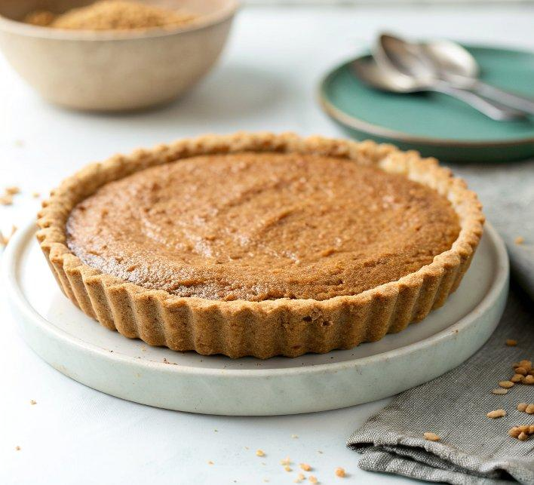

INGREDIENTS  - 32 Biscoff cookies (8.8 oz./250 g)  - 5 tbsp (71 g) unsalted butter, melted | PREP  COOK  1. Use a food processor or blender to grind the Biscoff cookies into fine crumbs. You can also place them in a zip-top bag and crush them into fine crumbs with a rolling pin and some arm muscle. You will have about 2 cups (480ml) crumbs.  2. In a medium bowl, stir the Biscoff crumbs and melted butter together until combined. The mixture will be thick, coarse, and sandy. Try to smash/break up any large chunks.  3. Pour the mixture into an ungreased 8-inch (20cm), 9-inch (23cm), or 10-inch (25cm) pie dish, cake pan, springform pan, or square pan. With medium pressure using your hand, pat the crumbs down into the bottom and up the sides to make a compact crust. Do not pack down with heavy force because that makes the crust too hard. Simply pat down until the mixture is no longer crumby/crumbly. Tip: You can use a small flat-bottomed measuring cup to help press down the bottom crust and smooth out the surface, but do not pack down too hard. If making a pie, run a spoon around the bottom “corner” where the edge and bottom meet to help make a rounded crust⁠—this helps prevent the crust from falling apart when you cut slices.  4. For a baked dessert, pre-bake this crust per your filling recipe’s directions. I usually pre-bake for 10 minutes at 350°F (177°C). For a no-bake dessert, cool the crust completely before using, unless your filling’s recipe instructs otherwise.  PLATING

