BIG PLATE CHICKEN WITH BELT NOODLES (大盘鸡)  COOK TIME: 25 min  SOURCE:  #comfort-food #hearty #spicy | 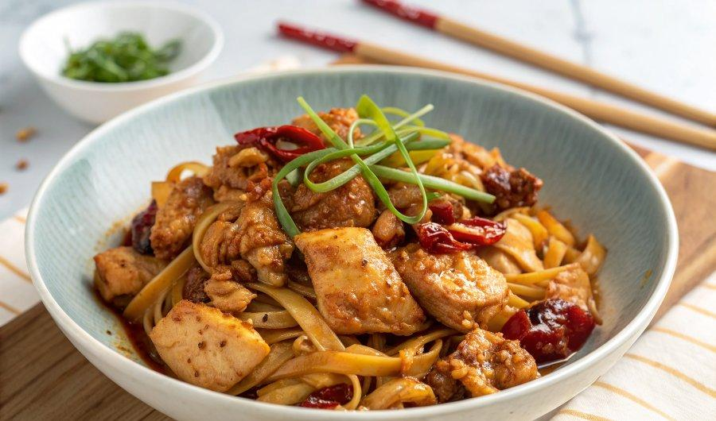

INGREDIENTS  - 300 g all-purpose flour  - 1/4 tsp salt  - 150 g water (see note 1)  - cooking oil (for coating the dough)  - 2 tbsp cooking oil  - 800 g chicken thigh, cut in chunks  - 1 1/2 tbsp Sichuan chilli bean paste  - 10 slice ginger  - 10 clove garlic  - 3 star anise  - 2 piece cassia cinnamon  - 1 bay leaf  - 1 handful dried chilli (or to taste)  - 1 tbsp Sichuan pepper  - 1 1/2 tbsp dark soy sauce  - 1 red bell pepper, cut in chunks  - 1 green bell pepper, cut in chunks  - 1 medium-sized potato, cut in thin pieces  - 1 onion, diced  - 3 stalks scallions, chopped  - coriander (optional) | PREP  COOK  1. Make & rest the dough (1 hour 15 mins)  2. Mix flour and salt. Add water gradually. Mix with chopsticks until no more loose flour can be seen.  3. Combine and knead briefly into a dough. Cover and leave to rest for 10 minutes. Knead again for about 2 minutes until very smooth (see note 2).  4. Divide the dough into 6 parts. Roll each piece into a gherkin shape.  5. Coat them with oil thoroughly. Cover with cling film then rest for at least 1 hour.  6. Cook the chicken & vegetables (20 mins)  7. Heat up the oil in a wok. Stir in the chicken. Fry until pale.  8. Add all the herbs, spices and seasonings for the chicken. Pour in 250ml (1 cup) hot water. Cover with a lid. Leave to cook for 10 mins.  9. Put in bell pepper, potato and onion (add some hot water if appear to be dry). Stir around then leave to cook for a further 5 mins until the vegetables become tender. Add scallions at the end.  1  0. Pulled and cook the noodles (5 mins)  1  1. When the dough is well rested, bring a large pot of water to a full boil.  1  2. While waiting, use a rolling pin to flatten each dough piece into a rectangle shape.  1  3. Pick up one piece by holding each end gently. Pull in opposite directions. The movement should be smooth and consistent.  1  4. As your arms move apart, bounce the noodle against the worktop to help it stretch further (Please refer to the tutorial video below). Drop the pulled noodle into boiling water.  1  5. Pull the second one and drop it in. Repeat until you finish all six pieces of dough. Leave to cook for 1-2 minutes (see note 3).  1  6. Assemble the dish  1  7. Transfer the noodles to a large serving plate/bowl using a pair of chopsticks.  1  8. Pour in the cooked chicken & vegetables.  1  9. Garnish with coriander if using. Stir well & enjoy immediately.  PLATING

