CHEESECAKE CARROT CAKE  COOK TIME: 40 min  SOURCE:  #sweet #baked #comfort-food | 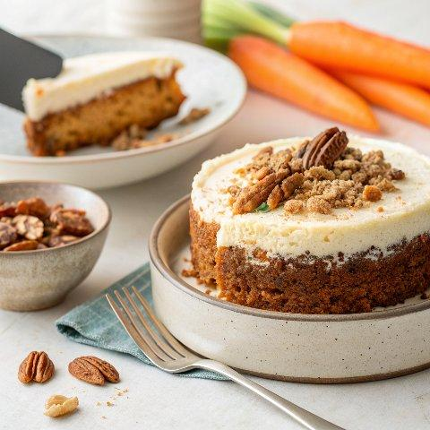

INGREDIENTS  - 2 cups (480ml) all-purpose flour  - 1 1/2 cups granulated sugar  - 1/2 cup packed light brown sugar  - 1 cup (240ml) pecans, (finely chopped (I use my food processor)  - 2 tsp baking soda  - 1 1/2 tsp baking powder  - 1 tbsp ground cinnamon  - 1/2 tsp EACH salt, allspice  - 1/4 tsp EACH ground nutmeg, ground ginger  - 4 large eggs (at room temperature)  - 1 8 oz. can crushed pineapple (1/2 cup), drained (packed in JUICE/not syrup)  - 3/4 cup vegetable oil  - 1/2 cup vanilla Greek yogurt (regular or lowfat)  - 1 tsp vanilla extract  - 9.5 oz peeled and finely, FRESHLY grated carrots (roughly 2 1/2 cups)  - 1 1/2 tsp unflavored gelatin  - 1 1/2 cups heavy cream, (divided)  - 6 oz baking white chocolate, (chopped)  - 16 oz cream cheese, ( softened)  - 1/2 cup granulated sugar  - 1 tbsp lemon juice  - 8 tbsp unsalted butter, (room temperature)  - 4 -4 1/2 cups powdered sugar  - 8 oz cream cheese cut into pieces, (room temperature)  - 1/2 cup pineapple preserves (optional, reduce sugar to 3 cups if omitting)  - 3/4 tsp vanilla extract  - 1/8 tsp salt, (plus more to taste) | PREP  COOK  1. TO MAKE CARROT CAKE  2. Preheat oven to 325°F (160°C). Line two 9” round cake pans with parchment paper or round silicone baking mats (these are my fav), then spray with nonstick cooking spray WITH FLOUR or grease and flour pans.  3. In a large mixing bowl, mix all of the Dry Ingredients together. In a separate bowl, gently whisk eggs then stir in remaining Wet Ingredients, EXCEPT the carrots, just until combined.  4. Fold Wet Ingredients into the Dry Ingredients just until moistened, then stir in the grated carrots just until evenly combined; DON’T overmix.  5. Divide batter equally between prepared pans. Drop the pans a few times on the counter to get rid of air bubbles. Bake at 325 F degrees for 25-30 minutes, or until a toothpick inserted into the center comes out clean and the cakes begin to pull away from sides of pans.  6. Let cakes cool in pans on wire racks for 15 minutes, then invert onto wire racks to cool completely, about 2 hours.  7. TO MAKE CHEESECAKE  8. Sprinkle gelatin over 1/2 cup heavy cream in a small saucepan; let sit 5 minutes. Cook mixture, while stirring, over low heat until the edges are just bubbling and the gelatin is completely smooth. Add the white chocolate and cook, stirring constantly, until just melted and smooth. Let cool slightly, about 10 minutes, while you IMMEDIATELY proceed with the next steps. (You don't want the chocolate to harden.)  9. Whip remaining 1 cup (240ml) heavy cream in a mixing bowl on medium-high speed until stiff peaks form (you can also use a stand mixer and transfer whipped cream to a bowl).  1  0. Fit stand mixer with the paddle attachment. Beat cream cheese and sugar on medium-high speed for 3 minutes, scraping down the sides of the bowl occasionally.  1  1. Reduce speed to medium-low and add lemon juice and white chocolate mixture; mix until just combined, scraping down bowl as needed. Using a rubber spatula, gently fold in the whipped cream.  1  2. TO ASSEMBLE  1  3. Watch video below if needed. Using a serrated knife, level the top of each cooled cake if needed. Set 1 cake round in a lightly greased, parchment paper lined springform pan cut side up; set aside the second cake round. (See notes if you don't have a springform pan.)  1  4. Evenly spread cheesecake filling over cake round in the springform pan. Place reserved cake round, cut side down, over the cheesecake. Cover with plastic wrap and refrigerate 6 hours, up to overnight.  1  5. TO MAKE THE FROSTING  1  6. You can make the frosting when needed, or anytime while the cheesecake is chilling, cover and refrigerate, then let it sit at room temperate for 15 minutes or so to soften before frosting.  1  7. Add butter and sugar (start with 3 cups sugar if omitting pineapple preserves, 4 cups sugar if using pineapple preserves) to a stand mixer fitted with the paddle attachment. Beat on medium-high speed until fluffy, about 2 minutes. Add cream cheese 1 piece at a time, and continue to beat until incorporated. Beat in pineapple preserves, vanilla and salt. If your frosting is too runny, add additional powdered sugar until it reaches desired consistency, then flavor with pinches of salt to taste, otherwise it will be too sweet. If the frosting is too thick, beat in one tablespoon of heavy cream at a time until it reaches desired consistency.  1  8. TO FROST CHEESECAKE  1  9. Run a thin knife between the carrot cake cheesecake and the side of the springform pan; remove pan. Transfer cheesecake to a serving plate or pedestal.  2  0. Spread frosting evenly over top and sides of cake as desired.  2  1. Cake is best served at room temperature.  PLATING

