BLUEBERRY PECAN BAKED OATMEAL  COOK TIME: 45 min  SOURCE:  #comfort-food #healthy #baked | 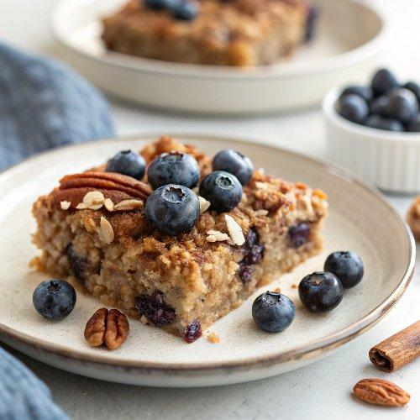

INGREDIENTS  - 2 cups (480ml) old-fashioned rolled oats (not instant)  - 2/3 cup (packed) dark brown sugar  - 1 cup (240ml) chopped pecans, (divided)  - 1 tsp baking powder  - 2 tsp ground cinnamon  - 1/4 tsp ground nutmeg  - 1/2 tsp salt  - 2 large eggs  - 1 2/3 cups milk  - 1 tsp vanilla extract  - 3 tbsp unsalted butter, (melted, plus more for greasing the dish)  - 2 1/2 cups blueberries, (divided)  - Lightly sweetened Greek yogurt, (for serving (optional) | PREP  COOK  1. Preheat the oven to 350°F (175°C) and set an oven rack in the middle position. Grease an 8-inch (20cm) or 2-quart (20-cm or 2-liter) baking dish with butter.  2. In a medium bowl, combine the oats, brown sugar, ¼ cup (30 g) of the nuts, baking powder, cinnamon, nutmeg, and salt. Mix well.  3. In another bowl, break up the eggs with a whisk; then whisk in the milk and vanilla until well combined. Add the milk mixture to the oat mixture, along with the melted butter.  4. Scatter 2 cup (480ml)s (280 g) of the blueberries evenly over the bottom of the prepared baking dish. Pour the oatmeal mixture over top and spread evenly. Sprinkle the remaining nuts and blueberries on top. Bake for 45 to 55 minutes, until the pecans on top are a rich brown color and the oats are set. Let cool for at least 5 minutes, then serve warm or at room temperature with Greek yogurt, if desired.  PLATING

