HOW TO COOK CORN ON THE COB  COOK TIME: 3 min  SOURCE:  #quick #grilled #summer | 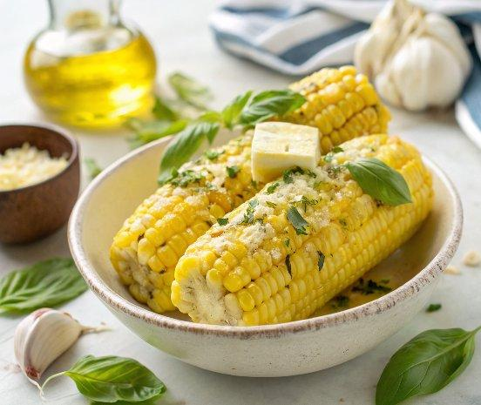

INGREDIENTS  - 4 ears fresh corn (husked)  - olive oil (butter, lemon, salt & pepper, for serving)  - 1/2 cup butter or vegan butter (at room temp)  - 1/4 cup fresh basil  - 1/2 clove garlic  - pinch of red pepper flakes  - sea salt and freshly ground black pepper  - adobo sauce from a can of chipotles in adobo  - crumbled cotija cheese  - chopped cilantro | PREP  COOK  1. In a large skillet, bring 1-inch (3cm) of water to a boil and add the corn in a single layer. When the water returns to a boil, reduce heat, cover and cook until hot, about 3 minutes. Drain.  2. Season with olive oil or butter, lemon juice, salt, and pepper, as desired.  3. Basil Butter Corn on the Cob: Blend softened butter with basil, garlic, red pepper flakes, salt and pepper. Slather it on corn with a squeeze of lemon.  4. Mexican Corn on the Cob: Brush the corn with adobo sauce and top with cotija cheese and cilantro.  PLATING

