TENDER GLAZED LAMB SHANKS  COOK TIME: 2h 12m  SOURCE:  #comfort-food #slow-cooked #hearty | 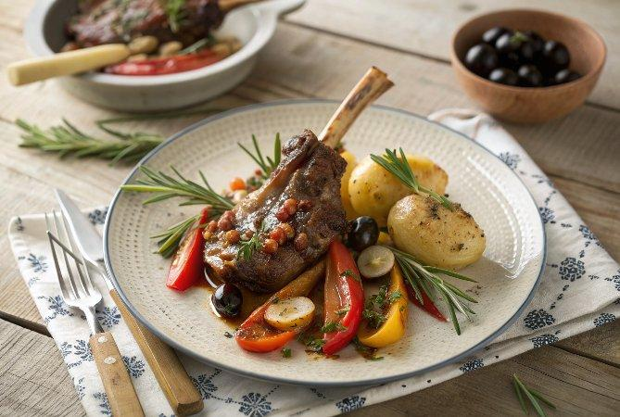

INGREDIENTS  - 4 higher-welfare lamb shanks (roughly 400 g each)  - olive oil  - 1 bulb of garlic  - 6 mixed-colour peppers  - 1 lemon  - 800 g baby new potatoes  - 8 black olives, stone in  - 1 tsp runny honey  - 1/2 a bunch of flat-leaf parsley (15 g) | PREP  COOK  PLATING

