SUAN CAI YU (酸菜鱼, SICHUAN FISH WITH PICKLED MUSTARD GREENS)  COOK TIME: 15 min  SOURCE:  #spicy #comfort-food #sichuan | 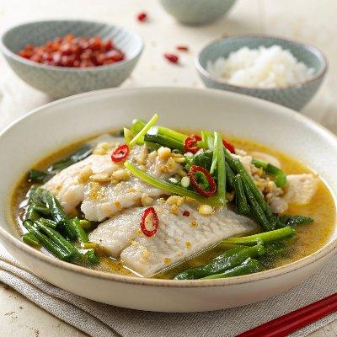

INGREDIENTS  - 1 lb (450 g) catfish filets (*Footnote 1)  - 1 egg white  - 1/2 tsp sea salt  - 1 tbsp cornstarch  - 1/4 tsp white pepper  - 1/3 cup dried chili pepper  - 4 green onions , white part sliced into 1/2” (1 cm) pieces, green part thinly sliced for topping  - 6 cloves garlic , minced  - 1 thumb ginger , minced  - 1 pack (10.5 oz / 300 g) Sichuan pickled mustard greens , rinsed with running tap water, drained and sliced into bite-sized pieces  - 1/2 cup Chinese pickled peppers , sliced (or keep them whole for a less spicy dish)  - 2 tbsp Shaoxing wine  - 4 cups (960ml) chicken broth  - 1 tsp sugar  - 1/4 tsp salt (or to taste)  - 1/4 tsp white pepper  - 5 to 10 fresh chili peppers , sliced (for garnish, very optional, use this only if you like the dish to be very spicy)  - 1/4 tsp ground Sichuan peppercorns  - 2 to 3 tbsp peanut oil  - 1 tsp green Sichuan peppercorn oil (Optional) | PREP  COOK  1. To marinate the fish  2. To slice the catfish, tilt the knife so it’s at 45 degrees against the cutting board. Slice fish into 1/2” (1 cm) thick slices.  3. Combine fish, white pepper, salt, egg white, and potato starch in a bowl. Gently mix the ingredients by hand, until the fish is evenly coated. Let marinate for 10 to 20 minutes while preparing other ingredients.  4. To cook the fish  5. Heat the oil in a deep large skillet (or a wok) over medium heat until hot. Turn to medium heat. Add green onion, garlic, ginger, and chili pepper. Cook and stir until very fragrant and the peppers just start to turn darker, 1 minute or so.  6. Add Sichuan pickles and pickled peppers. Cook and stir for 1 to 2 minutes. Add Shaoxing wine to deglaze the pan. Quickly stir a few times.  7. Add chicken stock and sugar. Cook over medium heat until boiling. Turn to medium heat and let the broth simmer for 3 to 5 minutes. Turn to low heat and taste the broth. Adjust seasoning by adding salt and white pepper, if needed. The broth should be slightly salty. Use a slotted ladle to transfer the pickles to a big serving bowl.  8. Turn to medium-high heat to bring the broth to a simmer. Add the fish slices, using chopsticks or a pair of tongs to gently separate the slices. Cook the fish in two batches if your pan is not big enough to spread all the fish slices into a single layer. Cook until the fish is just cooked through, 1 to 2 minutes. Using a slotted ladle to transfer the fish to the serving bowl on top of the pickles. Once the fish is cooked, turn to medium-high heat to bring the broth back to a boil.  9. Finish up the toppings  1  0. While the broth is cooking, sprinkle the green part of the green onions, sliced chili peppers (if using), and ground Sichuan peppercorn on top of the fish.  1  1. Heat the oil in another small saucepan until hot and just starting to smoke. Turn off the heat. Immediately drizzle the hot oil over the aromatics on top of the fish. You should see the hot oil bubbling. Drizzle a bit of green Sichuan peppercorn oil if using. Serve hot by itself or over rice as a main dish.  PLATING

