LEEK, PARSNIP AND CARROT FRYING PAN ROSTI  COOK TIME: 10 min  SOURCE:  #quick #comfort-food #frying-pan | 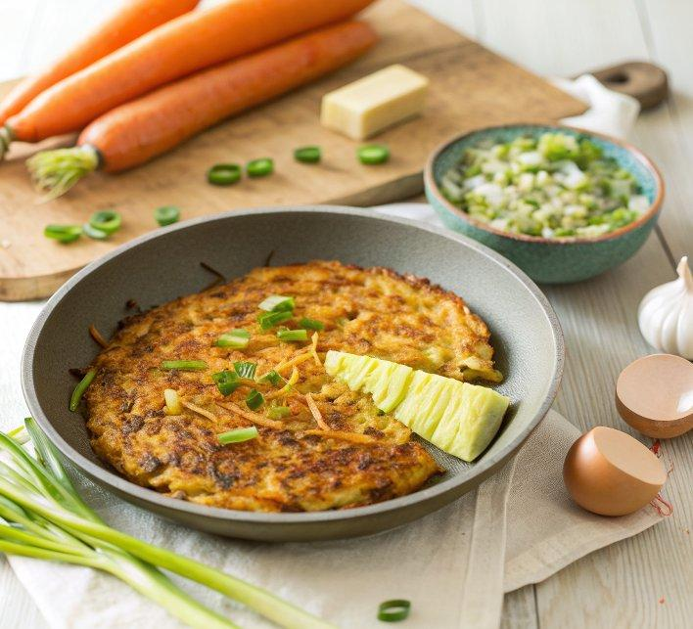

INGREDIENTS  - 1 large leek trimmed and thinly sliced  - 2 carrots grated  - 2 parsnips peeled and grated  - 2 garlic cloves finely chopped  - 1 egg lightly beaten  - 4 tbsp plain flour  - 1 tsp onion salt  - 2 tbsp unsalted butter  - 3 spring onions finely sliced, to serve  - small handful of thyme leaves to serve | PREP  COOK  1. Combine the leek, carrots, parsnips and garlic in a large bowl, then stir in the beaten egg. Combine the flour, onion salt and a grinding of black pepper, then stir this into the veg mixture until fully combined.  2. Melt the butter in a non-stick frying pan over a medium heat. Spoon in the veg mixture and press down lightly using a spatula so it covers the base. Cook for 5-6 mins until the spatula slides easily underneath. Carefully invert onto a plate, then slide back into the pan and cook on the other side for 5-6 mins until golden all over. Scatter over the spring onions thyme leaves, and serve sliced into wedges.  PLATING

