PERFECT PICKLED BEETS  COOK TIME: 45 min  SOURCE:  #pickled #vegetable #healthy | 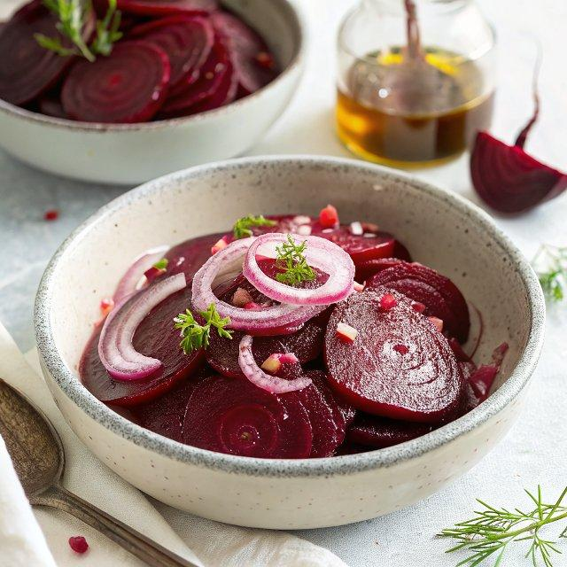

INGREDIENTS  - 4 medium beets  - 1 1/2 tbsp olive oil, for roasting  - A quarter of an onion, sliced 1/4-inch (10cm) thick  - 4 tbsp granulated sugar (50 g)  - 1 1/4 cups apple cider vinegar (295 ml)  - 1/2 tsp fine sea salt  - 1 whole clove  - 1 allspice berry, see notes | PREP  COOK  1. Roast Beets  2. Preheat the oven to 375°F (190°C). Set aside a large baking sheet.  3. Prepare the beets by removing the tops and roots, and then place them on a large sheet of aluminum foil or parchment paper. Drizzle olive oil over them, ensuring they are well coated, and fold up the foil or paper to create a sealed packet.  4. Place the packet on the baking sheet and roast in the oven until they are easily pierced with a fork, 45 to 55 minutes. Allow the beets to cool in the packet at room temperature or, better yet, refrigerate until cold.  5. Pickle the Beets  6. Peel the beets and slice them into 1/4-inch (10cm) thick pieces. If needed, use a vegetable peeler to help with the peeling. Pack the sliced beets tightly into a clean jar and add the sliced onions.  7. Heat the vinegar, sugar, salt, clove, and allspice berry in a small saucepan over medium-high heat until simmering and the sugar dissolves.  8. Pour the hot liquid over the onions and beets, leaving a 1/8-inch (20cm) gap between the pickle brine and the top of the jar. Place the lid on the jar and tighten it until finger-tight. Let cool to room temperature.  9. Once cooled, fully tighten the lid and store the jar in the refrigerator. Initially, place the jar upside down in a bowl and flip it right-side up after a day or two. Enjoy pickled beets as early as the next day. As long as the brine covers the beets and onions, they will last in the fridge for up to a month.  PLATING

