HAGGIS, NEEPS & TATTIES  COOK TIME: 30 min  SOURCE:  #comfort-food #traditional #hearty | 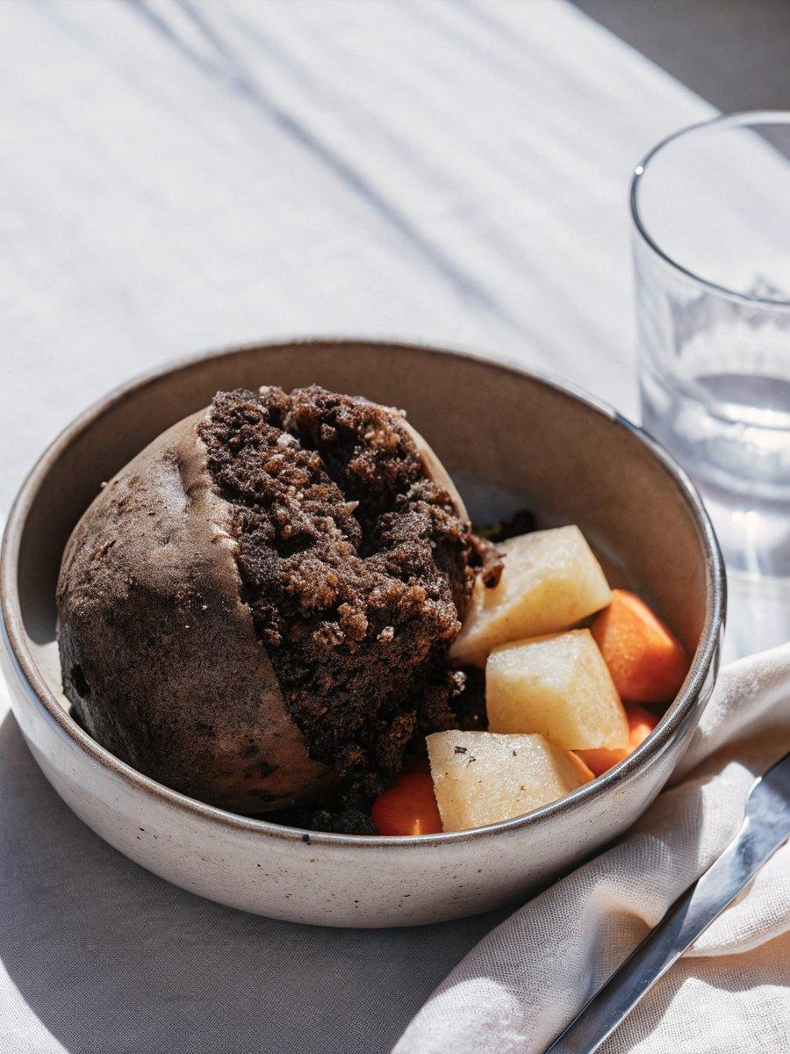

INGREDIENTS  - 500 g haggis  - 1 kg potatoes such as Maris Piper cut into similar-sized pieces  - 100 ml milk  - 150 g unsalted butter  - 1 swede peeled and diced  - 2 large carrots diced | PREP  COOK  1. Heat the haggis following pack instructions. When the haggis has 30 mins cooking time remaining, tip the potatoes into a large pan of generously salted cold water, then bring to the boil over a medium heat and cook for 10-12 mins until very tender when pierced with a fork. Drain well and leave to steam-dry in the colander for 10 mins.  2. Add half the milk and two-thirds of the butter to the pan used to cook the potatoes, and warm over a low heat until the butter is melted and the milk is just steaming. Remove from the heat and return the potatoes to a pan, then use a potato masher to mash everything together. Or, pass the potatoes through a medium sieve into the pan in batches using the back of a spoon or ladle. (Using a sieve will give you a very fine, no-lump texture.) Season well with salt and pepper.  3. Meanwhile, cook the swede and carrots in a pan of boiling water for 18-20 mins until very tender when pierced with a fork. Drain well and leave to steam-dry in the colander for 10 mins. Return the vegetables to the pan along with the remaining milk and butter, then coarsely mash using a potato masher – you don’t want a smooth texture here. Season well. Serve the haggis with the neeps and tatties alongside.  PLATING

