LEMON GARLIC HERB GRILLED SALMON  COOK TIME: 10 min  SOURCE:  #grilled #healthy #quick | 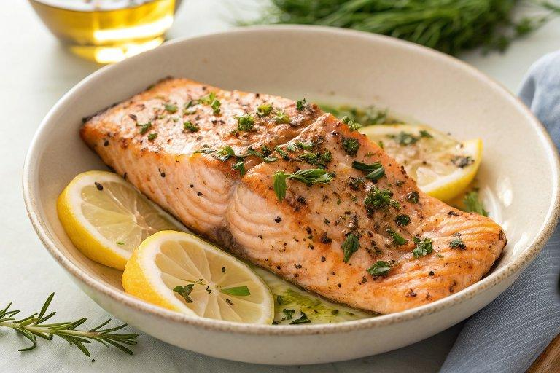

INGREDIENTS  - 4 (6 - 7 oz) skinless salmon fillets (*)  - 1/4 cup fresh lemon juice  - 1/4 cup olive oil, (plus more for brushing grill)  - 2 TBSP finely minced fresh parsley, (plus more for garnish)  - 4 tsp finely minced fresh rosemary  - 2 tsp finely minced fresh thyme  - 2 tsp minced garlic ((2 cloves))  - 2 tsp fresh lemon zest  - 1 tsp dijon mustard  - 1 tsp honey  - Salt and freshly ground black pepper | PREP  COOK  1. Place salmon in an 11 by 7-inch (18cm) dish.  2. In a small mixing bowl whisk together lemon juice, olive oil, parsley, rosemary, thyme, garlic, lemon zest, dijon mustard, honey, 1 tsp salt and 1/2 tsp pepper until well combined.  3. Pour mixture over salmon (lift fillets to help marinade run under) then cover and let marinate in refrigerator 30 minutes, turning once halfway through.  4. Preheat grill to medium-high heat during last 10 minutes of salmon marinating.  5. Brush grill grates with oil, spoon some of the herbs onto salmon (or just use your hands to spread them over), remove salmon from marinade and place on grill.  6. Grill about 3 - 5 minutes per side to cook through.  7. Serve warm garnished with more parsley if desired.  PLATING

