HAPPY & HEARTY SCOTTISH BROTH  COOK TIME: 1h 30m  SOURCE:  #comfort-food #hearty #stew | 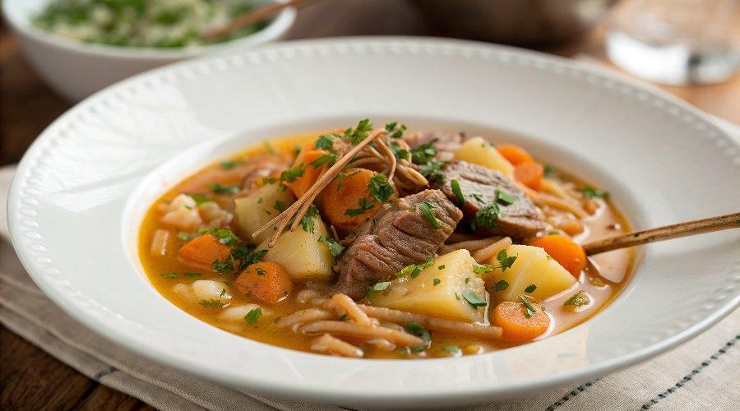

INGREDIENTS  - leftover lamb bones  - 200 g leftover cooked lamb  - 1 chicken or beef stock cube  - 200 g pearl barley  - 250 g swede  - 100 g turnip  - 2 carrots  - 250 g potatoes  - 1/2 a Savoy cabbage  - 100 g frozen peas  - extra virgin olive oil  - optional: leftover mint sauce  - crusty bread, to serve | PREP  COOK  PLATING

