TOM KHA GAI  COOK TIME: 10 min  SOURCE:  #comfort-food #spicy #quick | 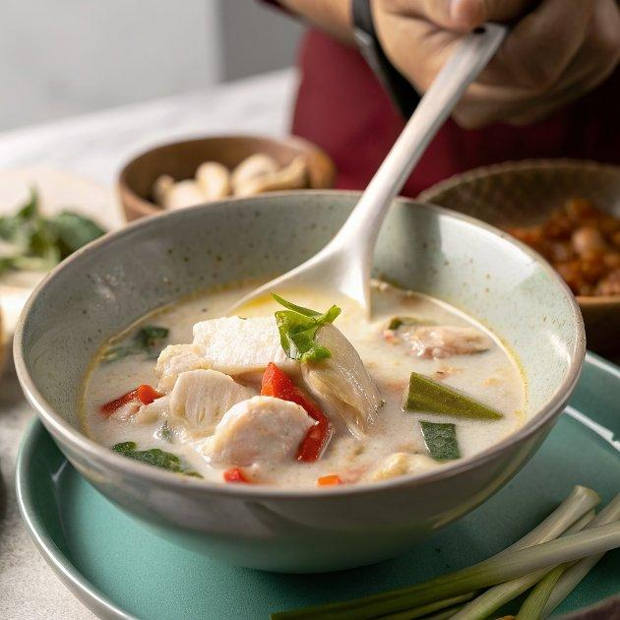

INGREDIENTS  - 800ml (3.3 cups) chicken stock  - 2 x 400 g cans coconut milk  - 2 tbsp galangal paste  - 2 stalks lemongrass trimmed, bruised and cut into large pieces  - 8 lime leaves torn in half  - 500 g skinless, boneless chicken thigh fillets thinly sliced  - 300 g oyster mushrooms cut into bite-sized pieces  - 4-6 bird's eye chillies according to your preference for heat, lightly bashed  - 1 tbsp caster sugar  - 3-5 tbsp fish sauce  - 2-3 limes juiced  - small handful of coriander leaves and steamed rice, to serve | PREP  COOK  1. Pour the chicken stock and coconut milk into a large saucepan set over a medium heat. Tip in the galangal, lemongrass and lime leaves, and bring to a gentle simmer, around 6-8 mins. Keeping at a gentle simmer, add the chicken. Cook for 8-10 mins until tender and cooked through.  2. Stir in the mushrooms and chillies, and simmer for a further 3-5 mins until everything is cooked through. Sprinkle in the sugar and 3 tbsp each of the fish sauce and lime juice. Taste and add the remaining if required.  3. Remove the galangal, lemongrass and lime leaves before serving using a slotted spoon. Ladle into bowls and serve with coriander leaves sprinkled over and steamed rice on the side. Will keep chilled for up to three days. Leave to cool first.  PLATING

